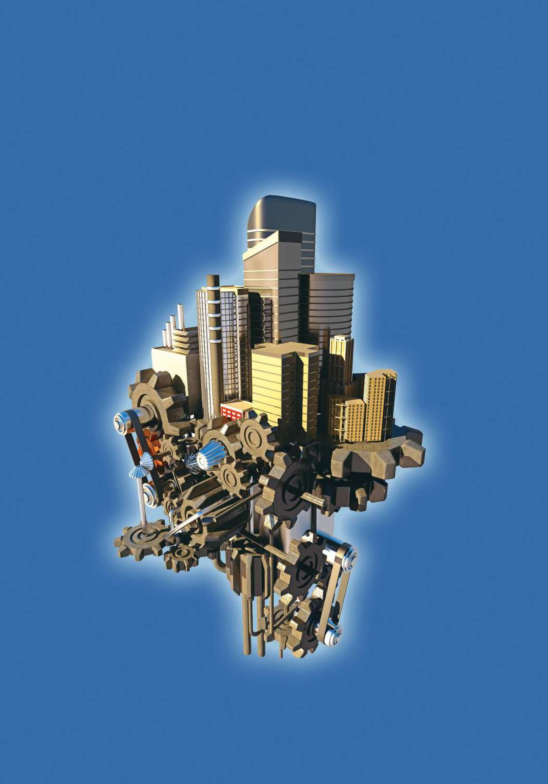

Introduction to

Static Analysis Using

SolidWorks Simulation

®

Radostina V. Petrova

## CHAPTER 6

|  |
| --- |
| ***STATIC ANALYSIS***  ***OF SOLID BODY***  ***WITH CIRCULAR OR***  ***PLANAR SYMMETRY*** |

### 6.1 DEVELOPMENT OF CAD MODELS OF THE ANALYSED BODIES

#### 6.1.1 Geometrical Model of a Body with Circular Symmetry

A CAD model of a wheel will be developed. At first, we will develop the entire wheel without considering any simplifications due to existing circular symmetry. Further, we will cut out only one repeating pattern, and finally, we will make a static study on the cut pattern.

All stages of geometrical modelling of the object are briefly outlined:

1. Start **a new model**:

File→New → Part→OK

Save file as **Wheel. sldprt**.

1. Define the used units – **System SI** of millimetre, gram and second units is selected.

Tools→Options→ Document Properties →Units→MMGS →OK

1. Draw the first sketch. This is a circle with a diameter of 80 mm, drawn in the **Front Plane**

Sketch→Front Plane →Circle→OK

(a) (b) 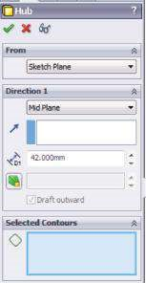

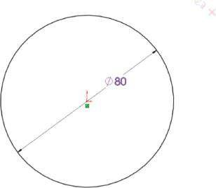

Ø80

(c) (d)

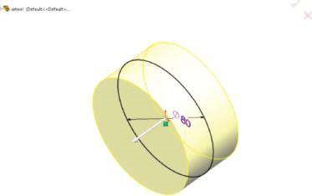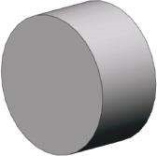

##### Fig u r e 6.1

*Development of the CAD model of the wheel – stages 3 and 4. (a) Sketch1 in Front Plane. (b) Hub Extrude property manager. (c) Graphic areas view while Extrude property manager is active. (d) Extruded Hub component.*

Automatically the sketch is indexed as **Sketch1** by the program (Figure

6.1a).

1. Extrude **Sketch1** to feature the hub (Figure 6.1):

Features→Extrude Boss/Base→OK

The options of that **Extrude Boss/Base** command () are shown in Figure

6.1b and are given as follows – From: Sketch Plane; Direction 1: Condition type Mid Plane; Direction of Extrusion ( ), nothing is picked as the direction is normal to the sketch plane; Depth ( ), 42 mm; Selected Contours (), no contour is picked as the entire sketch will be extruded.



1. Draw the second sketch in the **Right Plane** (Figure 6.2a):

Sketch→Right Plane→Sketch2 →OK

1. Revolve **Sketch2** and make the rim and web (Figure 6.2):

Features→Revolve Boss/Base→OK

(a) (b)

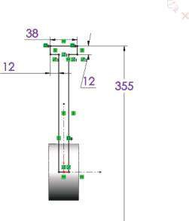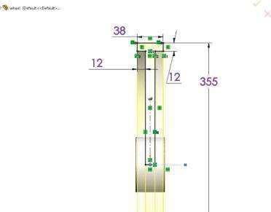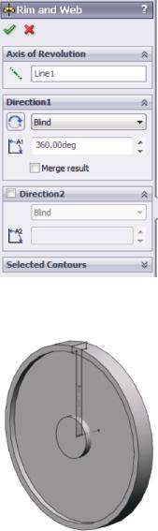

(

c

)

(

d

)

38

12

12

355

355

38

12

12

##### Figure 6.2

*Development of the CAD model of the wheel – stages 5 and 6. (a) Sketch2 in Front Plane. (b) Rim and Web Revolve property manager. (c) Graphic areas view while Revolve property manager is active. (d) Extruded Rim and Web component.*

The options of the **Revolve Boss/Base** command () are shown in Figure



6.2b and are given as follows – Axis of Revolution (): Line 1; Direction 1: Revolve type (), Blind to revolve the sketch in one direction; Angle of rotation () – 360.00 deg.

1. Draw the third sketch in the **Top Plane** (Figure 6.3a):

Sketch→Top Plane→Sketch3→OK

1. Extrude **Sketch3** to feature the rib (Figure 6.3):

Features→Extrude Boss/Base→OK

The options of the **Extrude Boss/Base** command () are shown in Figure 6.3b and are given as follows – From: Sketch Plane; Direction 1: Condition type – Mid Plane; Depth () – 6 mm.

(a)

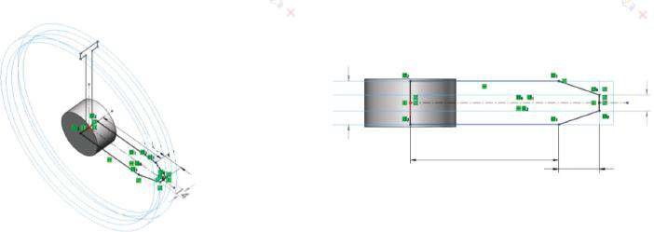

38

130

35.500

130

14

35.500

(b) 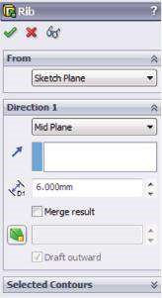 (c)

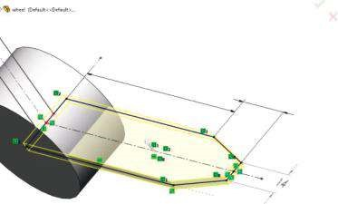

35.50

0

13

0

(d)

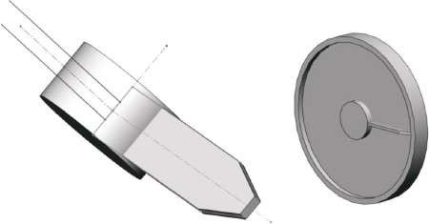

##### Figure 6.3

*Developm ent of the CAD m odel of the wheel – stages 7 and 8. (a) Sketch3 in Top Plane. (b) Rib Extrude property manager. (c) Graphic areas view while Extrude property manager is active.*

*(d) Extruded Rib component.*

1. Draw the fourth sketch in the **Front Plane** (Figure 6.4a):

Sketch→Front Plane→Sketch4→OK

The sketch is a circle with a diameter of 38 mm.

1. Extrude **Sketch4** to feature the cut through the hub (Figure 6.4b–d):

Features→Extruded Cut→OK

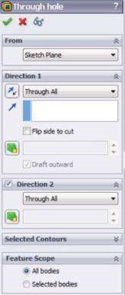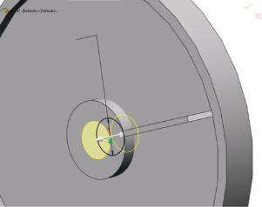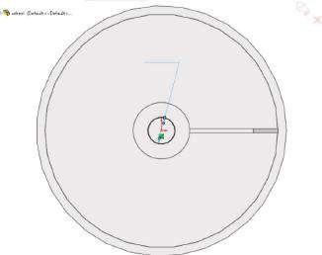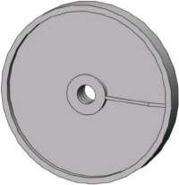

(

a

)

(

b

)

(

c

)

(

d

)

Ø38

Ø38

##### Figure 6.4

*Development of the CAD model of the wheel – stages 9 and 10. (a) Sketch4 in Front Plane. (b) Through hole extruded cut property manager. (c) Graphic areas view while Extruded Cut property manager is active. (d) Cut Through hole component.*

The options of **Extruded Cut** () are From: Sketch Plane; Direction 1: End condition type – Through all; Direction 2: End condition type – Through all; Feature Scope: All bodies.

1. Draw the fifth sketch in the **Front Plane** (Figure 6.5a):

Sketch→Front Plane→Sketch5→OK

1. Extrude **Sketch5** to feature the cut through the wheel (Figure 6.5b–d):

Features→Extruded Cut→OK

The options of **Extruded Cut** () are From: Sketch Plane; Direction 1: End condition type – Through all; Direction 2: End condition type – Through all; Feature Scope: All bodies.

This stage is similar to stage 10. As a result, the **Lightning hole** component is created.

(a)

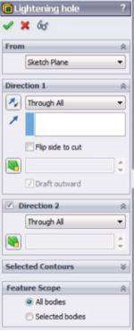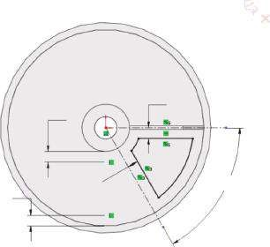

18

18

18

18

60

°

(

b

)

(c) (d)

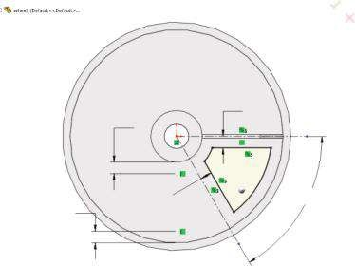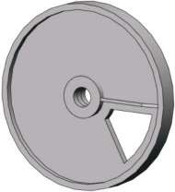

60

°

18

18

18

18

##### Fig u r e 6.5

*Developm ent of the CAD m odel of the wheel – stages 11 and 12. (a) Sketch5 in Front Plane. (b) Lightning hole extruded cut property manager. (c) Graphic areas view while Extruded Cut property manager is active. (d) Cut Lightning hole component.*

1. Feature the fillets at the edges of the lightning hole (Figure 6.6a–c):

Features→Fillet→OK

The options of the **Fillet** property manager () are Items to Fillet: Constant radius () – 9 mm; Items to fillet () – pick the four edges of the lightning hole; Full preview – checked; Setback parameters: no data are entered; Fillet Options: Select through faces – checked; Overflow type – Default.

1. Defining the central axis of the model – **Axis 1**:

Features→ReferenceGeometry→Axis→OK

The new axis will be defined as the axis of a cylindrical face (Figure 6.6e and f).

The options of the **Axis** property manager () are Reference entity ( ) – Face 1 (see Figure 6.6d). This is the guiding **Cylindrical/Conical Face** ().

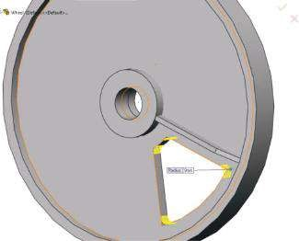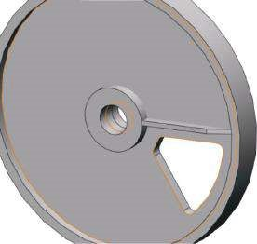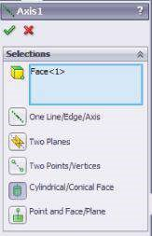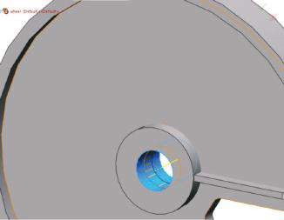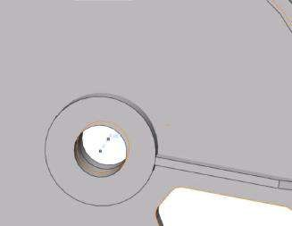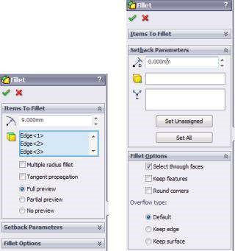

(

)

a

(

b

)

(

)

c

(

d

)(

e)

(

f

)

***Figure 6.6***

*Development of the CAD model of the wheel – stages 13 and 14. (a) Fillet property manager. (b) Selected edges preview. (c) Filleted Lightning hole com*

*-*

*ponent. (d) Axis property manager. (e) Selected reference entity. (f) Defined new axis – Axis 1.*

1. Copying some of the developed components using the **Circular Pattern** command:

Features→CirPattern→OK

The options of the **CirPattern** property manager ( ) are defined as follows (Figure 6.7a) – Parameters: Axis of rotation ( ) – Axis 1; Angle ( ) – sets the angle between the instances. It is equal to (360 deg/to the angle of the Lightning hole),

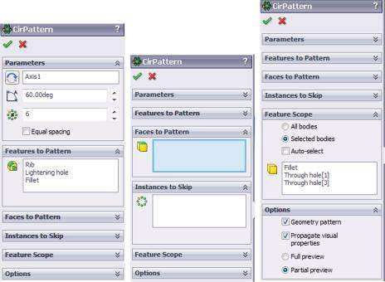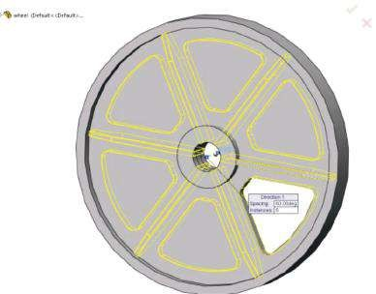

(

a

)

(

b

)

(c) (d)

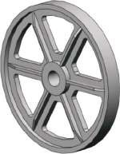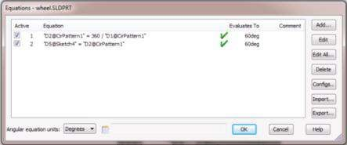

##### Fig u r e 6.7

*Development of the CAD model of the wheel – stages 15 and 16. (a) CirPattern property manager. (b) Graphic areas view while CirPattern property manager is active. (c) Patterned entities. (d) Defined equations.*

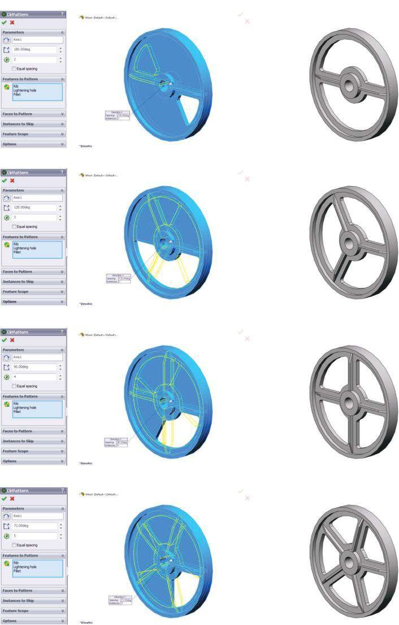

(

a

)

(

b

)

(

c

)

(

d

)

##### Figure 6.8

*Different modified models of the wheel. (a) The number of ribs is 2. (b) The number of ribs is 3.*

*(c) The number of ribs is 4. (d) The number of ribs is 5.*

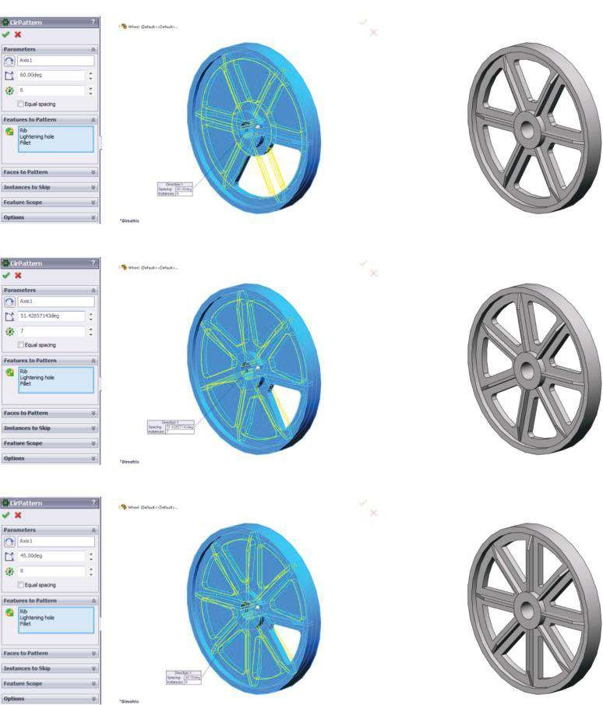

(

e

)

(

f

)

(

g

)

##### Figure 6.8 (Continued)

*Different modified models of the wheel. (e) The number of ribs is 6. (f) The number of ribs is 7. (g) The number of ribs is 8.*

which is set to 60.00 deg for **Sketch5**; Number of instances () – 6; Features to Pattern (): Rib, Lightning hole, Fillet; Faces to Pattern – no selection; Instances to Skip – no selection; Feature Scope: Selected bodies – checked; Bodies to Affect () – Fillet, Through hole [1], Through hole [3]; Options: Geometry patterns – checked; Propagate visual properties – checked; Partial preview – checked.

The **Graphic area** view and the ready model are shown in Figure 6.7b and c.

16. Defining equations to establish a relation between **Sketch5** and circular patterns (Figure 6.7d):

Tools→Equations→OK

Introducing these equations will enable easy modification of the wheel as far as the number of ribs is concerned. To change that number, it is enough to change the data in the **CirPattern** property manager according to Figure 6.8. It is enough to input the **Number of instances** () and, after that, to modify the **Angle** () to be equal to **360 deg/Number of instances**.

The **Graphic area** views and views of modified wheels are shown.

It is important to remember that if the number of ribs is 8 or larger, that is, the angle for each instance is 45° or larger. Otherwise, the fillets around the edges of the **Lightning hole** component could not be made due to geometrical interferences (Figure 6.8g).

For further finite element (FE) studies, the number of ribs is chosen to be 6.

Its change does not influence the suggested algorithm.

#### 6.1.2 Geometrical Model of a Body with Planar Symmetry

A body, representing a machine unit, which supports two small shafts (Figure 6.9), will be analysed. This machine unit possesses a planar symmetry, which will be used to make the FE simpler and to decrease the computer resources needed for the performance of the analysis.

At first, it will be briefly explained how to develop the CAD model of that machine unit in a SolidWorks environment. The included stages are as follows:

1. Start **a new model**:

File→New→ Part→OK

Save the file as **Machine_element. sldprt**.

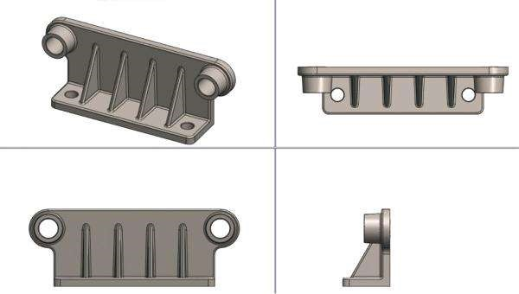

##### Fig u r e 6.9

*CAD model of the analysed machine unit.*

1. Define the used units – **System SI** of millimetre, gram and second (MMGS) units is selected.

Tools→Options→Document Properties→Units→MMGS→OK

1. Draw the first sketch in the **Front Plane** (Figure 6.10a):

Sketch→Front Plane→Circle→OK

Automatically the program indexes this sketch as **Sketch1**.

1. Extrude **Sketch1** to feature the **Boss_Extrude_1** component (Figure 6.10):

Features→Extrude Boss/Base→OK

The changed options of the **Extrude Boss/Base** property manager (), which feature that component, are shown in Figure 6.10b. They are From: Sketch Plane; Direction 1: Condition type () – Blind; Depth () – 8 mm.

1. Draw the second sketch. The plane of that sketch is the newly created front face of the **Boss_Extrude_1** component (Figure 6.11a and b). The sketch is **a rectangle** with a height of **8 mm** and a width equal to the width of **Boss_**

(a) (b) 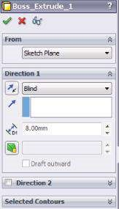

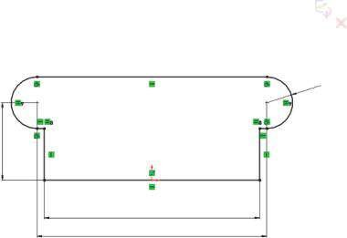

54

150

160

R18

(c) (d)

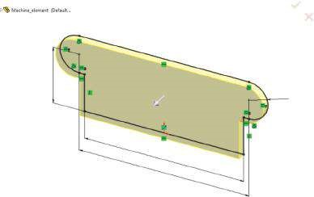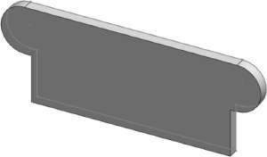

54

150

160

R18

##### Fig u r e 6.10

*Development of the CAD model of the machine element – stages 3 and 4. (a) Sketch1 in Front Plane. (b) Boss_Extrude_1 property manager. (c) Graphic areas view while Extrude property manager is active. (d) Extruded component.*

(b)

(c)

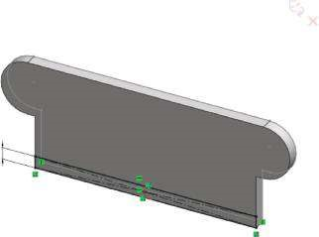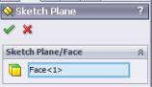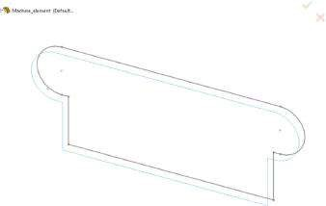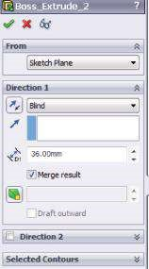

(

a

)

(

d

)

∞

(e) (f)

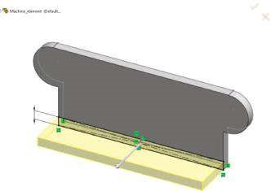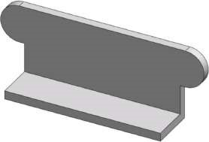

∞

##### Fig u r e 6.11

*Development of the CAD model of the machine unit – stages 5 and 6. (a) Sketch Plane property manager. (b) Picked Face <1>. (c) Ready Sketch2. (d) Boss_Extrude_2 property manager. (e) Graphic area view while Extrude property manager is active. (f) Ready Boss_Extrude_2 component.*

**Extrude_1**. The side lines of the rectangle coincide with the side edges of the created component (Figure 6.11c).

Sketch→Face <1>→Sketch2→OK

1. Extrude **Sketch2** and establish the horizontal component, denoted **Extrude_ Boss_2** (Figure 6.11d–f):

Features→Extrude Boss/Base→OK

The options of the **Extrude Boss/Base** command () are shown in Figure 6.11d. They are From: Sketch Plane; Direction 1: Condition type () – Blind; Depth () – 36 mm.

1. Feature the fillets at the edges of the components (Figure 6.12a–c):

Features→Fillet→OK

The options of the **Fillet1** property manager () are Items to Fillet: Constant radius () – 6 mm; Items to fillet () – pick the four edges of the model according to Figure 6.12b; Tangent propagation – checked; Full preview – checked; Setback parameters: no data are entered; Fillet Options: Select through faces – checked; Keep features – checked; Overflow type – Default.

1. Sketch the outer contour of the side cylinder (Figure 6.13a). This is a circle with a diameter of 28 mm.

Sketch→Face<1>→Sketch3→OK

1. Extrude **Sketch3** to make the side cylinder. This component is denoted **Extrude_ Boss_3** (Figure 6.13b–d):

Features → Extrude Boss/Base → OK

(a)

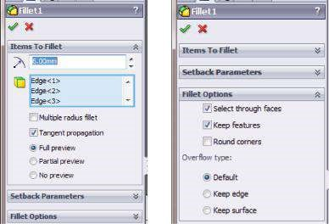

(b) (c)

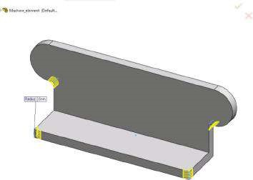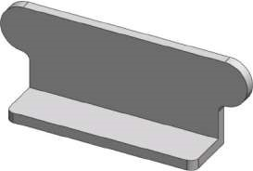

##### Fig u r e 6.12

*Development of the CAD model of the machine unit – stage 7. (a) Fillet property manager.*

*(b) Graphic area view of the picked edges. (c) Filleted components.*

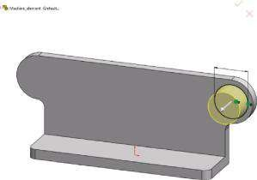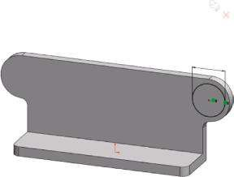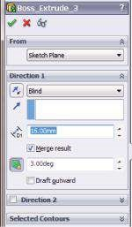

(

a

)

(

b

)

(

c

)

Ø28

Ø28

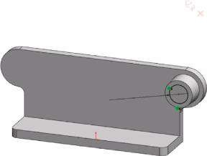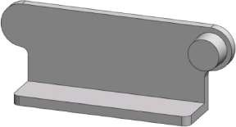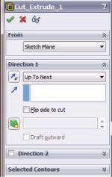

(

d

)

(

e

)

(

f

)

Ø18

(g) (h)

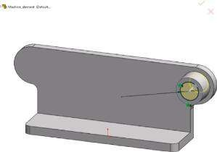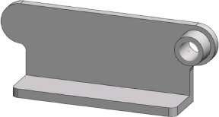

Ø18

##### Fig u r e 6.13

*Development of the CAD model of the machine unit – stages 8, 9 and 10. (a) Sketching the outer contour of the side cylinder. (b) Boss_Extrude_3 property manager. (c) Graphic area view while Boss_Extrude_3 property manager is active. (d) View of the extruded side cylinder. (e) Sketch of the hole contour. (f) Cut_Extrude_1 property manager. (g) Graphic area view while Cut_ Extrude_1 property manager is active. (h) Cut hole inside the side cylinder.*

The options of that **Extruded Boss/Base** command () are shown in

Figure 6.13b. They are From: Sketch Plane; Direction 1: Condition type () – Blind; Depth () – 16 mm; Draft () – 3.00 deg. This supposes a 3° inward draft to be added to the extruded feature.

1. Cut the hole inside the side cylinder (Figure 6.13e–h). The **Extruded Cut** () command is used to cut the hole through the cylinder and through the component **Boss_Extrude_1**.

Feature→Extruded Cut→OK

The options of the property manager are shown in Figure 6.13f.

1. Feature **Chamfer** () along the inner front edge of the cylinder (Figure 6.14):

Feature→Chamfer→OK

The chamfer properties, defined using an angle () and a distance () options of the property manager, are shown in Figure 6.14a.

1. Sketch the initial point/centre of the side hole:

Sketch→Face<1>→Sketch7→OK

The sketch is drawn in the bottom face horizontal component (Figure 6.15a). A point with the given coordinates is created (Figure 6.15b and c).

1. Defining a hole, using **Hole Wizard** (, Figure 6.15d–h):

Sketch→Hole Wizard→OK

The **Hole Specification Wizard** has two tabs (Figure 6.15d). The **Type** tab defines the type of the hole, while the **Positions** tab locates the position of the hole on planar or non-planar faces. The point defined in **Sketch8** will be used to locate the hole. As there is no predefined list of styles and we do not intend to keep the data for future projects, Favorite is not selected. Hole Type is defined by clicking on the selected type – Hole (); Standard – ISO; type – Drill sizes. Hole Specifications are as follows: Size – ϕ12.0; End Condition ( ) – Up To Next. No any Options defined.

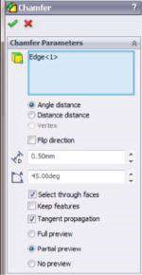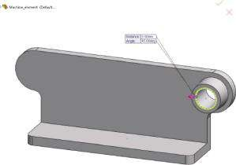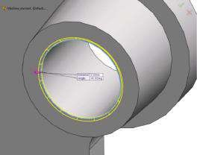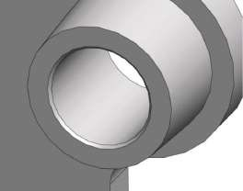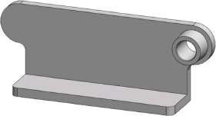

)

a

(

b

(

)

(

)

e

d

(

(

)

f)

Angle-distance

15

45

°

(c)

##### Fig u r e 6.14

*Developm ent of the CAD m odel of the m achine unit – stage 11. (a) Chamfer property m anager. (b) Angle-distance definition of a chamfer. (c) Graphic area view while Chamfer1 property m anager is active, including the introduced chamfer properties. (d) Detailed preview of the chamfered edge. (e) Chamfered edge – detailed view. (f) Chamfered edge.*

(a) (b) (c)

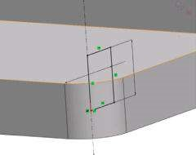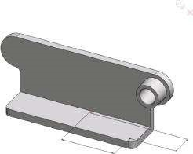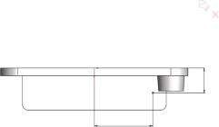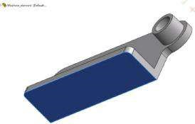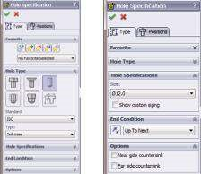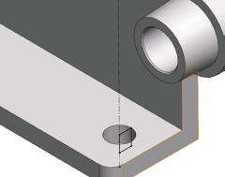

(

d

)

(

e

)

(

f

)

61

26

61

26

Ø1

2

8

(g) (h)

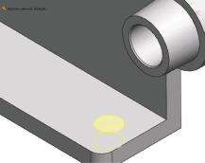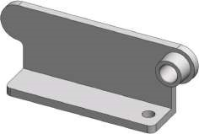

##### Fig u r e 6.15

*Development of the CAD model of the machine unit – stages 12 and 13. (a) Sketching plane for Sketch7. (b) Sketch7 – top view. (c) Sketch7 – trim etric view. (d) Hole Specification wizard. (e) Corresponding to Hole Wizard Sketch8. (f) Cut hole, viewing Sketch8. (g) Graphic area view while Hole Wizard property manager is active. (h) Cut hole.*

**Sketch8** (Figure 6.15e and f) is generated automatically as the **Hole Wizard** is activated and shows the axis, the diameter and the depth of the hole.

1. Mirror the side cylinder and the hole (Figure 6.16c):

Features → Mirror → OK

The options of the **Mirror1** property manager () are shown in Figure 6.16a. Mirror Face/Plane () is the **Right Plane** and Features to Mirror () are picked according to Figure 6.16b.

1. Define an auxiliary plane, parallel to the **Right Plane** (Figure 6.16d–f):

Features → Reference Geometry → Plane → OK

The options of the **Plane1** property manager () are given in Figure 6.16d.

**Plane1** is fully defined.

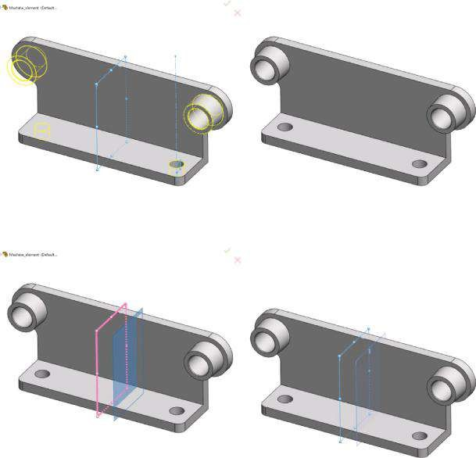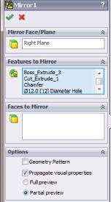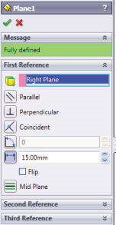

)

a

(

)

b

(

)

c

(

d

(

)

e

(

)

f

)

(

##### Fig u r e 6.16

*Developm ent of the CAD m odel of the m achine unit – stages 14 and 15. (a) Mirror1 property manager. (b) Graphic area view while Mirror1 property manager is active. (c) Mirrored entities. (d) Pane property m anager. (e) Plane1 at 15 mm distance of Right Plane. (f) Auxiliary Plane1.*

1. Sketch the rib in **Plane1** (Figure 6.17a). This is **Sketch9**. The rib is a triangle with angle of 60° and a side of 60 mm:

Sketch → Plane1 → Sketch9 → OK

1. Feature the rib () from **Sketch9** (Figure 6.17b). The rib is 4 mm thick and is formed as the sketch is in the middle of the volume (Figure 6.17c and d):

Features → Rib → OK

1. Feature the fillets at the front edges of the ribs (Figure 6.18a–c):

Features → Fillet → OK

The options of the **Fillet2** property manager ( ) are Items to Fillet: Constant radius () – 1.5 mm; Items to fillet ( ) – pick the front edges of the



(a) (b)

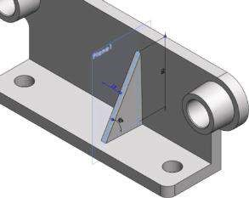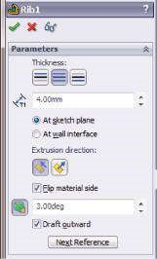

(c) (d)

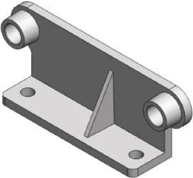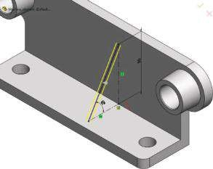

##### Fig u r e 6.17

*Developm ent of the CAD m odel of the m achine unit – stages 16 and 17. (a) Sketch9 in Plane1. (b) Rib1 property manager. (c) Graphic area view while Rib1 property manager is active. (d) Ready Rib1 view.*

ribs according to Figure 6.18a; Tangent propagation – checked; Full preview – checked, etc.

1. Pattern the rib in one direction. The **Linear Pattern** () command is used (Figure 6.19a–c).

Features → Linear Pattern → OK

The options of the **LPattern1** property manager (, Figure 6.19a) are Direction 1: Direction () – set to be parallel to **Edge<1>**, which is the blue crossing edge of both **Boss_Extruded** components; Spacing distance for patterns () – 30 mm; Number of Instances () – 2, including the original pattern; Direction 2: – no definition; Features to Pattern ( ) –Rib1; Fillet 2; Faces to Pattern () – no faces to pattern; no Instances to skip ( ); Options: Propagate Visual Properties and Partial preview are checked.



1. Mirror the patterned ribs (, Figure 6.19d–f):

Features → Mirror → OK

(a) 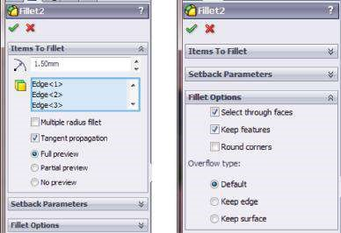

(b) (c)

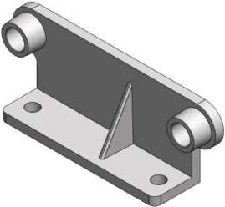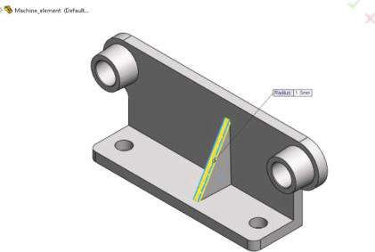

##### Fig u r e 6.18

*Development of the CAD model of the machine unit – stage 18. (a) Fillet2 property manager. (b) Picked edges to be filleted. (c) Filleted front edges of the ribs.*

The options of the **Mirror2** property manager are (Figure 6.19d): Mirror

Face/Plane (): **Right Plane**; Features to Mirror (): **Lpattern1** in the **Feature Manager** design tree is picked. The same signature is automatically displayed in the blue window; Options: Propagate Visual Properties and Partial preview are checked.

21. Feature the fillets at the edges of the components (Figure 6.20a–c):

Features → Fillet → OK

The options of the **Fillet3** property manager ( ) are Items to Fillet: Constant radius () – 1.5 mm; Items to fillet ( ) – the front vertical and the top horizontal faces of the components Boss_Extruded_1 and Boss_ Extruded_2 according to Figure 6.20b; Tangent propagation – checked; Full preview – checked, etc.



Further, more versions of that machine unit are suggested (Figures 6.21 and 6.22). The number and the distance between the ribs are changed through the commands **Plane1** (stage 15) and **LPattern1** (stage 19). The ratio of the distance between **Right Plane** and **Plane1** and the distance between the patterned ribs should always be 1:2. To design the fillets around faces (stage 21) successfully, the

(a) (b)

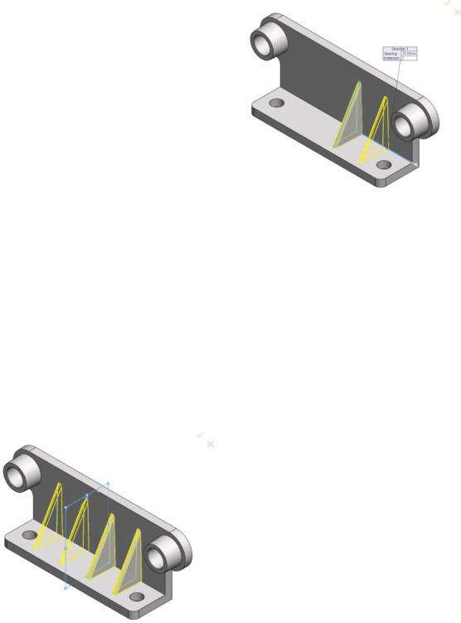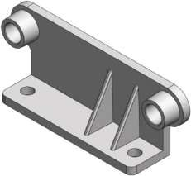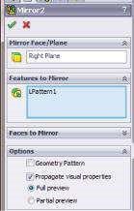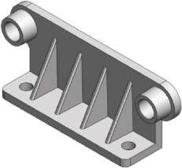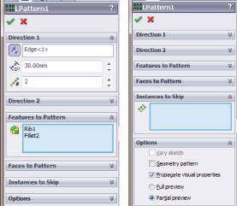

(

c

)

(

d

)

(

e

)

(

f

)

Machine_element (Default...

•

Isometric

Machine_element (D

efault...

Righ

t Plan

e

##### Fig u r e 6.19

*Development of the CAD model of the machine unit – stages 19 and 20. (a) LPattern1 property manager. (b) Graphic area view while LPattern1 property manager is active. (c) Patterned ribs. (d) Mirror2 property manager. (e) Graphic area view while Mirror2 property manager is active. (f) View of the mirrored ribs.*

distance between the end ribs, the hole and the fillet radius should be carefully calculated. Otherwise, no fillets will be set (Figure 6.22a and b).

We designed two CAD models of machine units in this section. These units have a circular and a planar symmetry.

We suggested a few modifications of these units varying the patterned commands used.

We learned how to modify symmetric CAD objects varying **CirPattern** or **LPattern** commands.

(a) (b) (c)

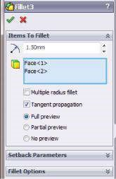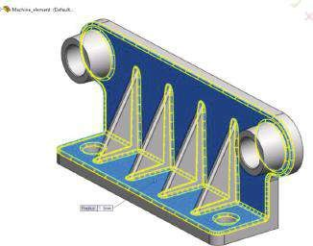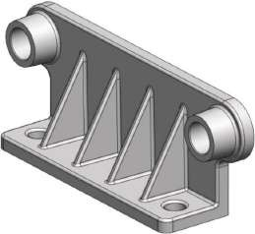

##### Figure 6.20

*Development of the CAD model of the machine unit – stage 21. (a) Fillet3 property manager.*

1. *Picked faces to be filleted. (c) Filleted com ponents.*

(a) (b)

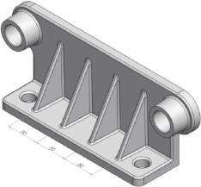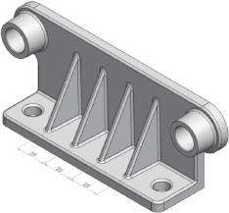

1. (d)

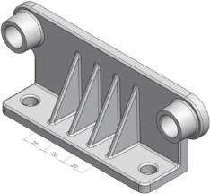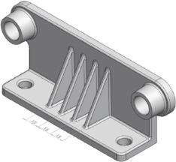

##### Fig u r e 6.21

*Some variation of this machine unit with 4 ribs. (a) Machine unit with 4 equidistant ribs at 30 cm (analysed further detail). (b) Machine unit with 4 equidistant ribs at 25 cm. (c) Machine unit with 4 equidistant ribs at 20 cm. (d) Machine unit with 4 equidistant ribs at 15 cm.*

(a) (b)

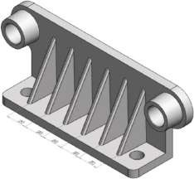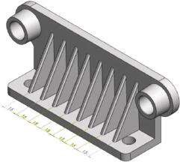

(c) (d) (e) (f)

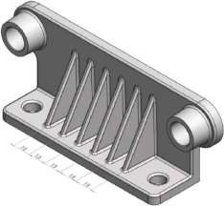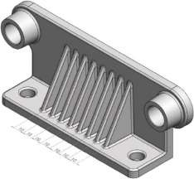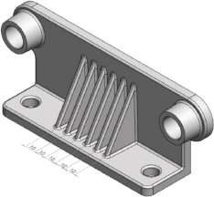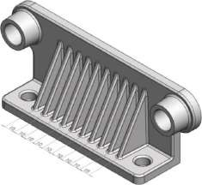

##### Figure 6.22

*Few m ore variations of this m achine unit with 6, 8 or 10 equidistant ribs. (a) Machine unit with 6 equidistant ribs at 20 cm. (b) Machine unit with 8 equidistant ribs at 15 cm. (c) Machine unit with 6 equidistant ribs at 15 cm. (d) Machine unit with 8 equidistant ribs at 10 cm. (e) Machine unit with 6 equidistant ribs at 10 cm. (f) Machine unit with 10 equidistant ribs at 10 cm.*

### 6.2 STATIC ANALYSIS OF THE DESIGNED SYMMETRICAL MACHINE UNIT WITH CIRCULAR SYMMETRY

#### 6.2.1 Why Use Symmetry and How It Works

Symmetry helps us in studying a segment of the model instead of the full model. It requires that geometry, restraints, loads and material properties of the model be symmetrical. The results of the ‘missing’ segments are deducted from the studied segment by the user, and thus, the ‘entire’ situation can be analysed. The symmetry helps us to reduce the size of the problem without any decrease in the results’ accuracy. The procedures of the application of the symmetrical restraints to solid meshes or to shell meshes using mid-surface are identical.

There are two main groups of symmetrical objects to be discussed:

* **Objects with a planar symmetry** where a segment of the object generated through a few cuts along symmetric planes is studied. Generally, this is a half or a quarter of the entire object. **Symmetry restraints** are applied to the cut sides to guarantee that the face is prevented from moving in its normal direction.
* **Objects with a circular symmetry** , or the so called axi-symmetrical objects. To analyse such a model, a single wedge can be used. Although the angle of the wedge is arbitrary in theory, using a very small angle may result in bad FEs at the tips, especially when there is no hole at the centre of the model. The **symmetrical restraints** are applied to the cut sides of the wedge, that is, to the faces of the symmetry. For solid models, they guarantee that every face that is coincident with a plane of symmetry is prevented from moving in its normal direction.

**Objects with a circular symmetry** are a part of the larger group of the axisymmetrical objects. When modelling such an object, circular patterns are used. When designing such an object, a representative segment can be studied. This segment can be a part or an assembly. The geometry, the restraints and the loading conditions are similar for all other segments that make up the model. Turbine, fans, flywheels and motor rotors can usually be analysed using circular symmetry.

**The Circular Symmetry restraints** can be applied for solid models and for static studies only. To define it, two similar planar sections and the axis of revolution for the symmetry must be defined. The program enforces equal translations at each pair of nodes, which possess similar relative positions on the two sections, that is, nodes on opposite sections with similar relative positions displace similarly. If the loads are such that the cut sections deform normally to their planes, **Circular Symmetry** restraints should be used. If the model has a circular pattern and the loads are such that the cut sections cannot deform normal to their planes, **Symmetry constraints** can be applied on the cut section.

**Circular symmetry** is more general as it can solve problems where the cut sections can deform in the deform in the tangential and in the normal directions.

For example, any wedge of the disc can be analysed (Figure 6.23a). If all forces are radial, the **Symmetry restraints** can be applied. If tangential loads exist, the cut sections can deform out of their planes and the **Circular Symmetry** must be used. For analysing a fan (Figure 6.23b), just one blade can be analysed. Since loads on the blades are usually tangential, using the **Circular Symmetry** is recommended.

Although any one-ninth of the model is a valid pattern, it is recommended to use a

(a) (b)

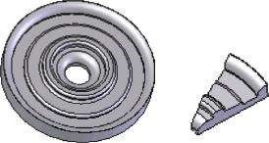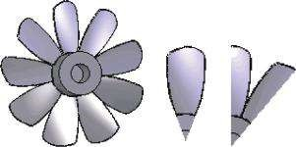

##### Figure 6.23

*Some examples of axi-symmetrical objects (SW Simulation on-line help). (a) A disc and a studied wedge. (b) A fan and two corresponding segments to be studied.*

pattern that does not cut through the blades, since the blades are exposed to spatial loading and deformations.

#### 6.2.2 Defining the Analysed Segment

We will now analyse the wheel designed in Section 6.1.1. This is a machine unit with a circular symmetry. If we analyse the entire model, this will require using much more computer resources and time, considering similar boundary conditions and mesh density.

Thus, if we have to analyse an object with a circular symmetry, it is always recommended to try to reduce the model relying on the assumption of existing symmetry.

As the wheel is an object that is axi-symmetric, it is enough to analyse only the onesixth segment of the model.

At first, we have to identify that segment. The cuts can pass either through the ribs (Figure 6.24a) or through the middle of the lightning holes (Figure 6.24b). The advantages of the first identified segment compared to the second one concern the deformations and the stress–strain distribution inside the wheel in relation to the loading in the provided additional examples. As the cuts of the segment pass through the ribs, that is, through the more rigid components of the object, the expected boundary deformations will be less. Thus, the impact of the definition of symmetrical boundary conditions and of the analysis of a segment of the wheel instead of the entire wheel will be reduced compared to the version when cuts pass through lightning holes (Figure 6.24b).

The next stage is cutting the identified segment. To do so, further steps should be performed:

1. Defining the intersection of the wheel with the **Top Plane** (Figure 6.25a and b) Sketch→Convert Entities() →Intersection Curve() →OK

Pick the **Top Plane** from the floating **Design Tree** at the **Graphics area** as well as all faces that the **Top Plane** intersects (Figure 6.25d). Pick the faces of the rib that lies at 180° of the initial one. Otherwise, you could have problems; creating the mesh for the software automatically generates two interfering bodies. Their signatures are automatically displayed in the blue window in the **Intersection Curve** property manager (Figure 6.25c). After clicking **OK**,

(a)

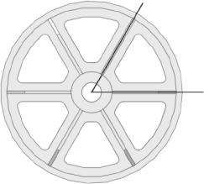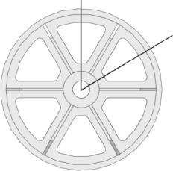

(

b

)

##### Figure 6.24

*Identifying the analysed segm ent. (a) Segm ent with cuts through the ribs. (b) Segm ent with cuts through the lightning holes.*

(a) (b) (c)

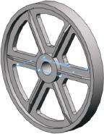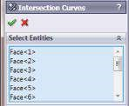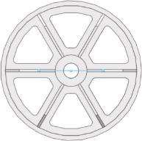

(d) (e)

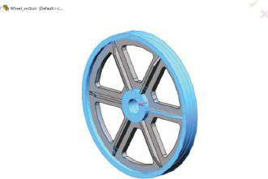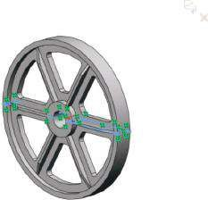

(f) (g)

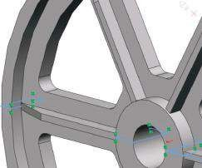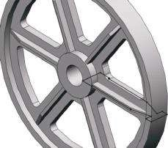

##### Fig u r e 6.25

*Defining the intersecting contour – Sketch6. (a) Trimetric view of the intersection of the wheel and Top Plane. (b) Front view of the intersection of the wheel and Top Plane. (c) Intersection Curves property manager. (d) All picked intersected faces. (e) Intersection curve, defined as an open sketch. (f) Intersection curve, defined as an open sketch – detailed view. (g) Sketch6.*

the intersecting curve appears as an open contour (Figure 6.25e). The lines of that contour that are at the opposite rib and remain open must be deleted as a prerequisite to the success of the next operation (Figure 6.25f).

Sketch→Trim() →Trim to closest() →OK

The **Trim** command is used to draw the sketch as a closed contour (**Sketch6**, Figure 6.25g).

2. Featuring the segment with the **Cut-Revolve** () command

Feature→Cut-Revolve→OK

The options of the **Cut-Revolve** property manager are given in Figure 6.26a. The section will be revolved around **Axis1** (Axis of Revolution, ), clockwise

(a) (b)

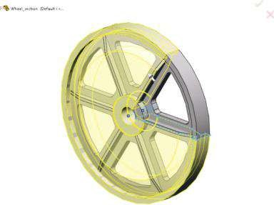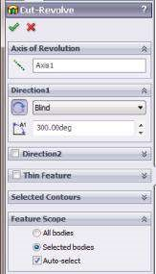

(c) (d)

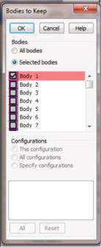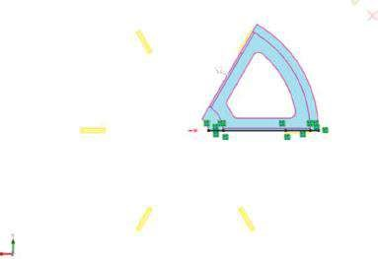

(e) (f)

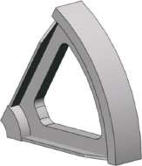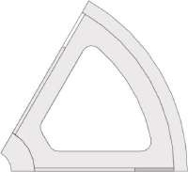

##### Figure 6.26

*Cutting the segment to be studied. (a) Cut-Revolve property manager. (b) Graphic area view while Cut-Revolve property manager is active. (c) Bodies to keep property manager. (d) Selected body to be kept – coloured in blue. (e) The cut segment – trimetric view. (f) The cut segment – front view.*

(Blind, ), at an angle () of 300deg. The cut material is coloured in yellow in the **Graphics area** and the kept bodies – in grey (Figure 6.26b). Clicking on the **OK** button opens a new **Bodies to Keep** window (Figure 6.26c), where all bodies are listed, and the user must check the signatures of the bodies to be kept. Only the first and the second bodies, which are coloured in blue in Figure 6.26d, will be kept, that is, only their signatures are selected.

Views of the cut segment are shown in Figure 6.26e and f.

#### 6.2.3 Static Study of a Body with Circular Symmetry and Symmetrical Loads

The segment will be studied under symmetrical loading. If the wheel operates as a transferring element between a pipe and a shaft, in which the diameter is much smaller than the inner diameter of the pipe (Figure 6.27a), such a type of loading will be generated. It is supposed that the wheel is steadily pressed in the pipe. Thus, the inner surface of the pipe will generate **auniform pressure** normal to the outer surface of the wheel. The thin shaft acts as a supporting component of the entire wheel–pipe unit. Hence, it can be modelled as **a fixture**, whose type will be specified further in this study. The free-body spatial scheme of the wheel, including the loading (the red arrows) and the fixture (the green symbols), is shown in Figure 6.27b.

To perform the static study of the wheel, only one-sixth segment will be used. It has already been shown how this segment could be cut from the entire model.

A new study titled **Symmetrical_Study_Fixed_Geometry** is started.

The development of the **FE model** starts with setting the material. It is the **Gray Cast Iron**, selected from the **SW Materials** library:

Name of the part (right click) →Apply/Edit Material() →SolidWorks Materials→

Iron→Gray Cast Iron→Apply→Close

The **Gray Cast Iron** is a linear isotropic material, which have the following material properties: modulus of elasticity – 66,178 MPa; Poisson’s ratio – 0.27; shear modulus – 50,000 MPa; mass density – 7200 kg/m3; tensile strength – 151.66 MPa; compressive strength – 572.17 MPa. The cast iron is **a brittle material**, and hence no yield strength is defined and the default failure criterion is according to the **Mohr–Coulomb theory**. Further, the pressure loads are applied:

SW Simulation analysis tree → External Loads (right click) →Pressure()

A uniform pressure, normal to the selected surface, will be applied to the outer surface of the wheel (Figure 6.28b) with a value of 5 MPa (Figure 6.28a).

The next task is to define the fixtures. At least two types of fixtures should be defined. The first type replaces the shaft impact on the wheel, and the second type ‘tells’ the software that the studied segment is a piece of a larger model. It is questionable how exactly the shaft interacts with the wheel and which is the best fixture to be

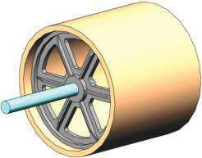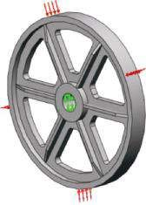

(

a

)

(

b

)

##### Figure 6.27

*Studied shaft wheel–pipe unit. (a) CAD model of the machine unit. (b) Free-body scheme of the wheel.*

(a) (b)

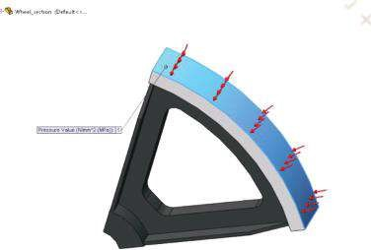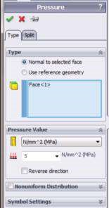

##### Figure 6.28

*Applying the pressure. (a) Pressure property manager. (b) Pressure symbols and loaded face.*

applied. This strongly depends on the type of joining of both elements. Thus, three different versions of the union are modelled and studied:

* If we assume that the wheel is fixed to the shaft and the shaft is **rigid**, the shaft can be replaced with the **Fixed Geometry** fixture. This study is titled **Symmetrical_Study_Fixed_Geometry**. The effect is similar if a rigid **Bearing** fixture is introduced.
* Another option to be studied is as follows: if we assume that the joining of the wheel to the shaft is implemented through a damper with known damping properties, and enable a free radial, circumferential or axial motion within predefined limits, then **Advanced Fixture on Cylindrical Faces** is used. This study is titled **Symmetrical_Study_Advanced_Fixture**.
* If we assume that the shaft is deformable and there is a bearing connector between the shaft and the wheel, a **Bearing Fixture** is recommended. Probably, this is the most common case if torsion is applied. This study is titled **Symmetrical_Study_Bearing_Fixture**.

The first study to be performed is the **Symmetrical_Study_Fixed_Geometry** study, where a **Fixed Geometry** fixture is applied (Figure 6.29):

SW Simulation analysis tree →Fixtures(, right click)→ Fixed Geometry ()

While the first fixture is different for all case studies, the second fixture replaces the ‘missing’ part of the wheel and is similar in all studied cases. This is a **Circular Symmetry** fixture, which belongs to the group of **Advanced Fixtures** (Figure 6.30a):

SW Simulation analysis tree → Fixtures (, right click)→ Advanced Fixtures →

Circular Symmetry ()

The faces to which the restraints are applied are the side faces of the segment and are coloured in blue and in violet for each cutting plane (Figure 6.30b). The symmetrical axis is introduced by selecting **Axis1** from the floating **Design tree** on the **Graphics area** and is coloured in pink (Figure 6.30).

(a) (b)

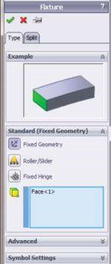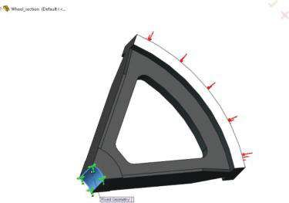

##### Figure 6.29

*Applying the Fixed Geometry fixture to the wheel segment. (a) Fixture property manager – Fixed Geometry fixture. (b) Fixed Geometry face.*

(a) (b)

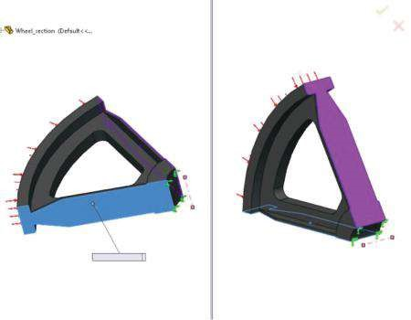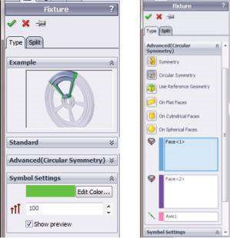

Axis1

Circular Symmetry:

Axis1

##### Figure 6.30

*Applying the Circular Symmetry fixture. (a) Circular Symmetry fixture property manager. (b) Faces, where Circular Symmetry boundary conditions are applied and the corresponding circular axis.*

Another alternative to define the symmetry restraints in this case is the use of the **Symmetry** fixture (Figure 6.31a):

SW Simulation analysis tree → Fixtures (, right click)→ Advanced Fixtures →

Symmetry ()

The faces to which these new restraints should be applied are the side faces and are coloured in blue (Figure 6.31b). This alternative is applicable only if the applied loading does not deform the symmetrical faces out of their planes.

(a) (b)

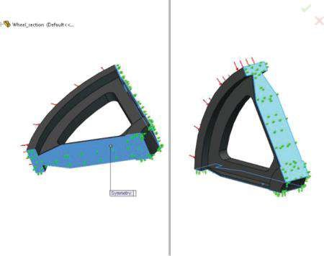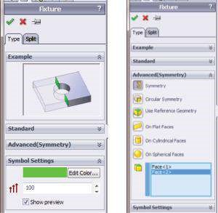

##### Fig u r e 6.31

*Applying the Symmetry fixture. (a) Symmetry fixture property manager. (b) Faces, where Symmetry boundary conditions are applied.*

Yet, considering our intention to use the developed FE model for further analysis where the wheel will be exposed to torsion **‘Circular Symmetry,’** a fixture is preferred.

The next stage is to define mesh properties. Generally, this operation is done after fixtures and loads are defined, as they are a part of the defined boundary conditions. The mesh that will be created at that stage will be used within all the following studies. The options of the **Mesh** property manager are shown in Figure 6.32a. A curvaturebased mesh with the following properties is generated (Figure 6.32b): Jacobian points – 29; Max Element Size – 6 mm; Min Element Size – 2 mm; Total nodes – 19,899; Total elements – 11,836 (Figure 6.32c). The highest Aspect ratio is 530.8, and it is related to a few elements at the joint between the rib and the rim (the red areas, Figure 6.32d).

If you have any problems with mesh generation, this could be due to the interference or the existence of more than one component, which the software generates automatically within the model. The easiest way to overcome that problem is to create incompatible meshes. This can be done in a few different ways:

• Through the **Component Contact** property manager – Start **Component Contact** property manager (Figure 6.33a).

SW Simulation analysis tree → Connections (, right click) → Component Contact

() → OK

Then select the **Bonded (No clearance) Contact type** to ensure the continuity of the model and the transfer of loads between the selected bodies, that is, it guarantees that the selected bodies will behave as if they were welded during simulation. The program creates a **compatible mesh** on contacting areas. This means that the program merges coincident nodes along the common interface (Figure 6.33c). Bonding with a compatible mesh produces more accurate results in the bonded regions than bonding with an incompatible mesh, but it can cause meshing to fail for some assemblies. If so, the remeshing of the failed parts with an incompatible mesh can help (Figure 6.33d).

(a) (b)

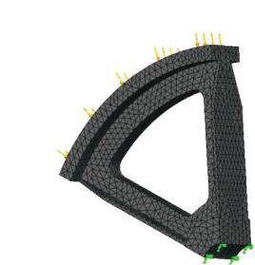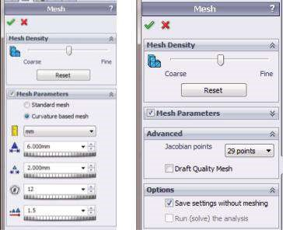

Model name: Wheel_section

Study name: Symmetric Study_Fixed_Geometry

Mesh type: Solid mesh

(c) (d)

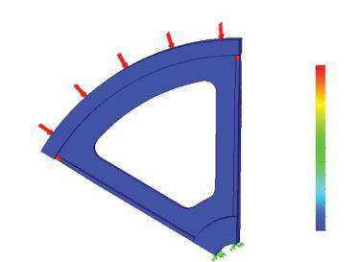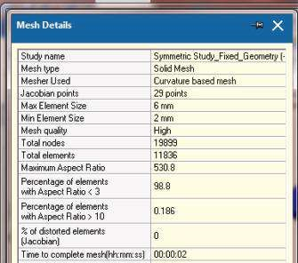

Model name: Wheel_section

Study name: Symmetric Study_Fixed_Geometry

Plot type: Aspect ratio Mesh Quality1

Aspect Ratio

5.308e+002

4.867e+002

4.425e+002

3.984e+002

3.542e+002

3.101e+002

2.659e+002

2.218e+002

1.777e+002

1.335e+002

8.937e+001

4.523e+001

1.084e+000

##### Figure 6.32

*Meshing the object. (a) Mesh property manager – curvature-based mesh. (b) Plot of the created m esh. (c) Mesh details. (d) Aspect Ratio plot.*

Then, the program meshes each component independently and uses multipoint restraints internally. Bonding incompatible meshes can generate local stress concentrations in the bonded areas. The **Bonding incompatible mesh** is activated for every component contact separately.

* Through the **Mesh** property manager – Check **Remesh failed parts with incompatible mesh** in the **Advanced** sub-window (Figure 6.33b).

SW Simulation analysis tree →Mesh (right click) → Create Mesh () → OK

* Through the **Simulation toolbar**, following the path (Figure 6.33c)

Simulation → Option → Default Options → Mesh →Mesher Settings → Remeshed failed parts with incompatible mesh

If this option is on, the options are active for the entire part/assembly and the software tries incompatible meshing automatically for solids that fail to mesh with the compatible option.

(a) (b) (c)

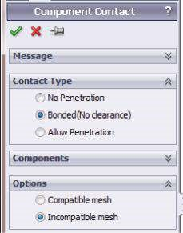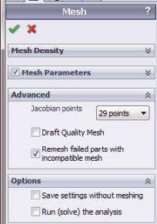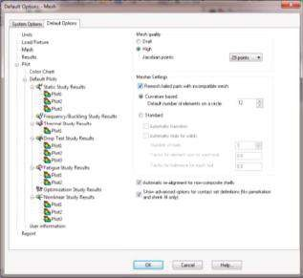

(d) (e)

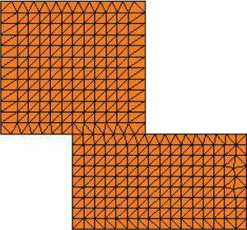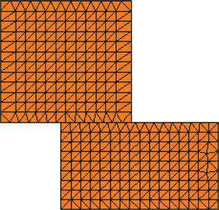

##### Fig u r e 6.33

*Bonding bodies (SW Simulation On-line Help). (a) Component Contact property manager. (b) Mesh property m anager. (c) Mesh options. (d) Bonding with com patible m esh. (e) Bonding with incom patible m esh.*

Finally, the object is meshed and the study is run. The FE model has 59,262 DOFs and the calculation runs for about 9 s. All the above model properties are the same as the properties of the FE model of the entire wheel, are exposed to the same restraints and are meshed with a similar mesh (Figure 6.34).

The wheel mesh consists of 105,500 (compared to 19,899 for the wheel segment) nodes and 65,376 (compared to 11,836) elements. The highest **Aspect Ratio** is 853.68 (compared to 530.8) and is for the few elements at the joints between the ribs and the rim as is the wheel segment model. The solver runs a model of 314,490 (compared to 59,262) DOFs for about 12 s (9 s runs the wheel segment model). All values in the brackets are for the segmented wheel model. Now, it is easy to compare the complexity of both models, especially regarding the necessary computer resources. As the FE model is a relatively easy model, its complexity is not a crucial point for the study.

However, if a more complicated assembly model is studied, the use of circular symmetry to simplify the FE model can be of real help.

Table 6.1 provides the results of three different case studies concerning the complexity of the FE models – the entire wheel model and the two wheel segment models. The percentage of discrepancy is calculated through comparing the values of segmented models to those for the entire wheel. All provided values show a good coincidence.

(a) (b)

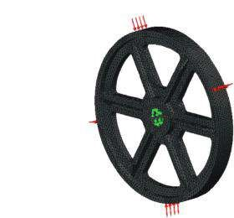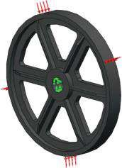

Model name: Wheel

Study name: Study 1

Mesh type: Solid mesh

***Figure 6.34***

*FE m odel of the entire wheel. (a) Model restraint. (b) Plot of the m esh.*

***Table 6.1***

#### Numerical Results for the Entire Wheel and for the Segmented Wheel Models

**Entire**

**Wheel Segment, Formed by Cuts Segment, Formed by Cuts**

**Model through the Ribs through Lightening Holes**

|  |  |  |  |  |  |
| --- | --- | --- | --- | --- | --- |
|  | **Value** | **Value** | **Discrepancy** | **Value** | **Discrepancy** |
| Von Mises Stress,  Max Element Mode (MPa) | 94.3 | 92.9 | 1.48 | 94.1 | 0.21 |
| Von Mises Stress,  Max Node Mode (MPa) | 110.3 | 106.3 | 3.69 | 105.9 | 3.99 |
| Principal Stress P1,  Max Element Mode (MPa) | 11.2 | 11.1 | −0.89 | 11.2 | 0 |
| Principal Stress P3,  Min Element Mode (MPa) | −98.7 | −98.1 | 0.61 | −99.1 | −0.41 |
| Maximum  D isplacement (mm) | 8.751e−02 | 8.75e−02 | 0 | 8.753e−02 | −0.02 |
| Factor of Safety, Minimal Value | 5.1 | 4.04 |  | 5.1 |  |

The extreme values of P1 and P3 in the node mode appear in one of the nodes of the FE with the highest aspect ratio. Therefore, these results are not reliable and they are omitted in the table.

Finally, we can conclude that the numerical calculations for segmented models can successfully replace those for the entire complex model. However, it is necessary to keep in mind that the user himself or herself has to transfer the segmented results to the entire model.

The corresponding plots are shown in Figure 6.35.

1. Model name: crankpulley

Study name: Study1

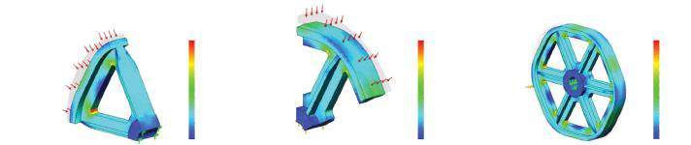

Model name: Wheel_section

Study name: Symmetric Study_Fixed_Geometry

Plot type: Static element stress Stress1

Deformation scale: 200

Model name: Wheel_section_Test_case

Study name: Symmetric Study_Fixed_Geometry

Plot type: Static element stress Stress1

Deformation scale: 200

Plot type: Static element stress Stress1

von Mises (N/mm

2

(MPa))

von Mises (N/mm

2

)

(MPa

))

von Mises (N/mm

2

)

(MPa

))

94.3

86.5

78.8

71.0

63.2

55.4

47.8

39.9

32.1

24.3

16.5

8.7

1.0

94.1

86.4

78.5

70.9

63.1

55.4

47.8

39.9

32.2

24.4

16.7

8.9

1.2

92.9

85.3

77.5

70.0

62.3

54.7

47.1

39.4

31.8

24.1

16.5

8.8

1.2

Deformation scale: 200

1. Model name: Wheel_section_Test_case

Study name: Symmetric Study_Fixed_Geometry Plot type: Static element stress Stress2 Deformation scale: 200

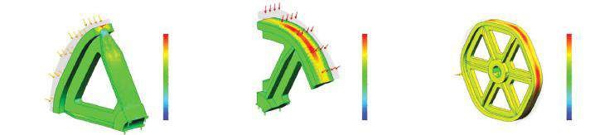

Model name: Wheel_section

Study name: Symmetric Study_Fixed_Geometry

Plot type: Static element stress Stress2

Deformation scale: 200

Model name: crankpulley

Study name: Study1

Plot type: Static element stress Stress1

Deformation scale: 200

P1 (N/mm

2

(MPa))

P1 (N/mm

2

(MPa))

P1 (N/mm

2

(

MPa

))

11.2

8.4

5.5

2.6

-0.3

-3.2

-6.0

-8.9

-11.8

-14.7

-17.5

-20.4

-23.3

11.2

9.5

7.8

6.1

4.4

2.7

1.0

-0.7

-2.4

-4.1

-5.8

-7.5

-9.2

11.1

9.2

7.3

5.4

3.5

1.6

-0.3

-2.2

-4.1

-6.1

-7.9

-9.8

-11.7

(c)

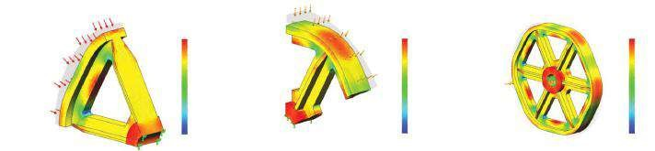

Model name: Wheel_section

Study name: Symmetric Study_Fixed_Geometry

Plot type: Static element stress Stress3

Deformation scale: 200

Model name: Wheel_section_Test_case

Study name: Symmetric Study_Fixed_Geometry

Plot type: Static element stress Stress3

Deformation scale: 200

Model name: crankpulley

Study name: Study1

Plot type: Static element stress Stress1

Deformation scale: 200

P3 (N/mm

2

(MPa))

P3 (N/mm

2

(MPa))

P3 (N/mm

2

(MPa))

-0.8

-8.5

-17.0

-25.2

-33.3

-41.5

-49.7

-57.8

-66.0

-74.2

-82.4

-90.5

-96.7

-0.8

-8.9

-17.1

-25.3

-33.5

-41.7

-49.9

-58.1

-66.3

-74.5

-90.9

-99.1

-0.8

-5.9

-17.0

-25.1

-33.2

-41.3

-49.5

-57.5

-65.7

-73.5

-81.9

-90.0

-98.1

(d)

Study name: Symmetric Study_Fixed_GeometryModel name: Wheel_section_Test_case Model name: crankpulleyStudy name: Study1

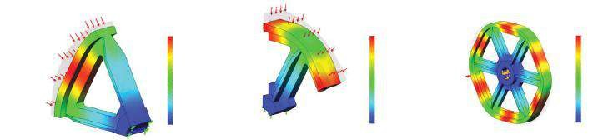

Model name: Wheel_section

Study name: Symmetric Study_Fixed_Geometry

Plot type: Static displacement Displacement1

Deformation scale: 200

Plot type: Static displacement Displacement1

URES (mm)

URES (mm)

8.751e-002

8.022e-002

7.293e-002

6.564e-002

5.834e-002

5.105e-002

4.375e-002

3.646e-002

2.917e-002

2.188e-002

1.459e-002

7.293e-003

URES (mm)

8.751e-002

8.022e-002

7.293e-002

6.563e-002

5.834e-002

5.105e-002

4.376e-002

3.646e-002

2.917e-002

2.188e-002

1.489e-002

7.293e-003

1.000e-030

8.753e-002

8.024e-002

7.294e-002

6.585e-002

5.835e-002

5.106e-002

4.377e-002

3.647e-002

2.918e-002

2.198e-002

1.458e-002

7.294e-003

1.000e-030

Plot type: Static displacement Displacement1 Deformation scale: 200 Deformation scale: 200

(e)

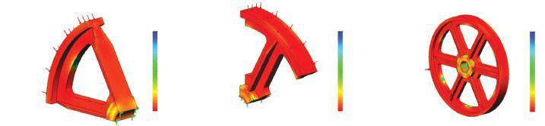

Model name: Wheel_section

Study name: Symmetric Study_Fixed_Geometry

Plot type: Factor of Safety Factor of Safety1

Criterion: Automatic

Factor of safety distribution: Min FOS = 4

Model name: Wheel_section_Test_case

Study name: Symmetric Study_Fixed_Geometry

Plot type: Factor of Safety Factor of Safety1

Criterion: Automatic

Factor of safety distribution: Min FOS = 5.1

Model name: crankpulley

Study name: Study 1

Plot type: Factor of Safety Factor of Safety1

Criterion: Automatic

Factor of safety distribution: Min FOS = 5.1

FOS

FOS

851.93

FOS

763.05

699.89

638.73

573.56

510.40

447.24

384.07

320.91

257.75

194.58

131.42

58.26

5.10

781.37

710.60

640.24

569.67

499.11

428.54

357.98

287.41

216.84

146.28

75.71

5.15

597.28

547.83

496.38

448.96

399.52

350.08

300.65

251.22

201.70

152.35

102.91

53.47

4.04

##### Fig u r e 6.35

*Plots of the results of the three models. (a) Plot of von Mises stresses. (b) Plot of principle stresses P1. (c) Plot of principle stresses P3. (d) Plot of the displacem ent. (e) Factor of safety plots.*

Further, the results of some additional studies with different fixtures to model the supporting shaft are given. The studied models are as follows:

• **Study 1** – It is titled **Symmetrical_Study_Advanced_Fixture** and an **Advanced Fixture on Cylindrical Faces** is applied. The properties of the fixture are given in Figure 6.36a. It enables radial motion of 0.02 mm and torsion of 0.5° (Figure 6.36b). Some plots of the result are also shown (Figure 6.36c–h).

(a) (b)

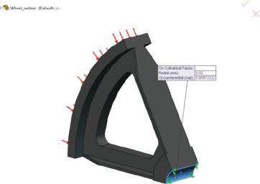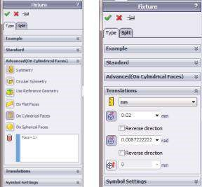

(c) (d)

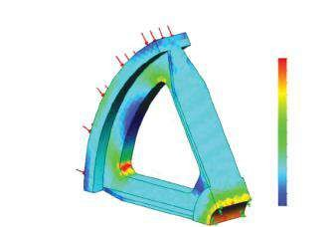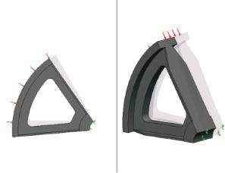

Mo

del name: Wheel_section

Study name: Sy

mmetric Study_Advanced_Fixture

Plot ty

pe: Static displacement Displacement2

De

formation scale: 10

Model name: Wheel_section

Study name: Symmetric Study_Advanced_Fixture

Plot type: Static displacement Displacement2

Deformation scale: 10

Model name: Wheel_section

Study name: Symmetric Study_Advanced_Fixture

Plot type: Static element stress Stress1

von Mises (N/mm

2

(MPa))

96.3

87.4

79.5

71.6

63.7

55.8

47.8

39.9

32.0

24.1

16.2

8.3

0.4

(e) (f) (g) (h)

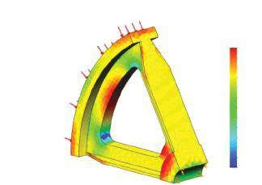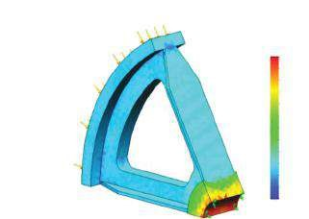

Mo

del name: Wheel_section

Study name: Sy

mmetric Study_Advanced_Fixture

Plot ty

pe: Static element stress Stress2

Model name: Wheel_section

Study name: Symmetric Study_Advanced_Fixture

Plot type: Static element stress Stress3

P3 (N/mm

2

(MPa))

P1 (N/mm

2

(MPa))

54.8

49.2

43.6

38.0

32.4

26.6

21.2

15.6

10.0

4.5

–1.1

–6.7

–12.3

–101.1

–92.6

–84.2

–75.8

–67.4

–59.0

–50.5

–42.1

–33.7

–25.3

–16.9

–8.4

–0.0

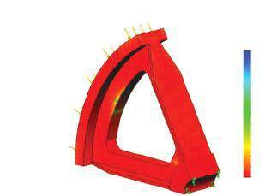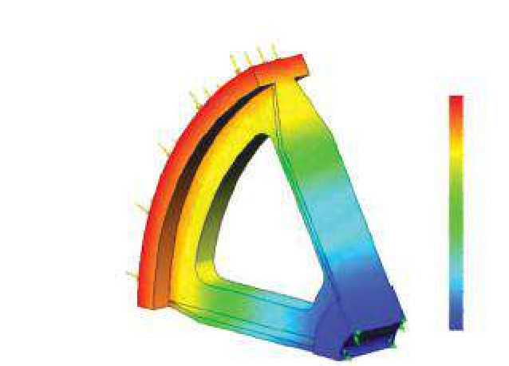

Model name: Wheel_section

Study name: Symmetric Study_Advanced_Fixture

Plot type: Static displacement Displacement1

Model name: Wheel_section

Study name: Symmetric Study_Advanced_Fixture

Plot type: Factor of Safety Factor of Safety1

Criterion: Automatic

Factor of safety distribution: Min FOS = 2.1

URES (mm)

FOS

1.603e+000

1.655e+000

1.708e+000

1.760e+000

1.812e+000

1.864e+000

1.916e+000

1.969e+000

2.021e+000

2.073e+000

2.125e+000

2.176e+000

2.230e+000

2.07

104.72

207.37

310.02

412.67

515.32

617.97

720.62

823.27

925.92

1028.57

1131.22

1233.87

##### Figure 6.36

*Plots of the results of Symmetrical_Study_Advanced_Fixture. (a) On Cylindrical Faces property manager. (b) Graphical view of On Cylindrical Face fixture. (c) Deformed shape. (d) von Mises plot. (e) First Principle Stress plot. (f) Third Principle Stress plot. (g) Displacement plot. (h) Factor of Safety plot.*

(a) (b) (c)

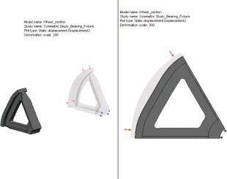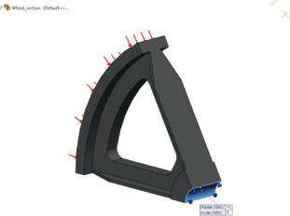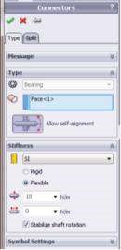

Model name: Wheel section

Study name: Symmetric Study_Bearing_Fixture

Plot type: Static displacement Displacement2

Deformation scale: 200

Model name: Wheel section

Study name: Symmetric Study_Bearing_Fixture

Plot type: Static displacement Displacement2

Deformation scale: 200

(d) (e) (f)

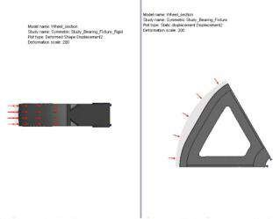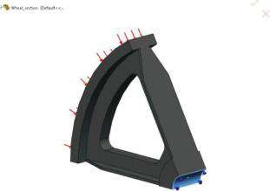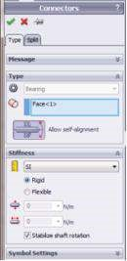

Model name: Wheel section

Study name: Symmetric Study_Bearing_Fixture_Rigid

Plot type: Deformed Shape Displacement2

Deformation scale: 200

Model name: Wheel section

Study name: Symmetric Study_Bearing_Fixture

Plot type: Deformed Shape Displacement2

Deformation scale: 200

##### Fig u r e 6.37

*Applying different bearing fixtures. (a) Bearing Fixture property manager. (b) Graphic view of the flexible bearing. (c) Deformed shape of flexible Bearing_Fixture study. (d) Bearing Fixture property manager – rigid bearing. (e) Graphic view of the rigid bearing. (f) Deformed shape of rigid Bearing_Fixture study.*

* **Study 2** – This study is titled **Symmetrical_Study_Bearing_Fixture** and uses the **Bearing Fixture** (, Figure 6.37a and b). The **Self-aligning** option (), which allows an unrestricted off-axis shaft rotation, is active. The fixture is **Flexible** with **Radial** resistance () of 10 N/m and no ability to resist to **Axial** displacement (). To prevent rotational instability, caused by torsion, and to avoid numerical singularities, the **Stabilize shaft rotation** is checked. The deformed form is shown in Figure 6.37c. The fixture allows free motion along the axis of the wheel. Regarding that criterion, this fixture can be compared to the **Cylindrical Faces** fixture, which also frees that motion in the input limits. The difference is in the way of introduction of these limits – either through the displacement range for the **Cylindrical Faces** fixture or through axial and radial resistance for the **Bearing** fixture.
* **Study 3** – It is titled **Symmetrical_Study_Bearing_Fixture_Rigid** and the applied **Bearing Fixture** (, Figure 6.37d and e) is **Rigid**. The deformed form is shown in Figure 6.37f. It is obvious that regarding the deformations, the rigid bearing acts as a **Fixed Geometry** fixture.

***Table 6.2***

#### Numerical Results for the Segmented Models, Restrained by Different Fixtures (Scenario 1)

**Bearing Fixture Studies with**

**Study with Study with**

**Axial Bearing Resistance Equal to**

**Fixed Cylindrical**

|  |  |  |  |  |  |
| --- | --- | --- | --- | --- | --- |
|  | **Geometry Fixture** | **Faces Fixture, Study 1** | **10 N/m Study 2** | **5 N/m** | **0 N/m Study 3** |
| **von Mises Stress (MPa)** Element mode – max | 92.9 | 95.3 | 92.9 | 92.9 | 92.9 |
| Node mode – max | 106.3 | 108.5 | 106.3 | 106.3 | 106.3 |
| **Principal Stress P1 (MPa)** Element mode – max | 11.1 | 54.8 | 11.1 | 11.1 | 11.1 |
| Node mode – max | 33.7 | 61.1 | 34.4 | 34.4 | 34.4 |
| **Principal Stress P3 (MPa)** Element mode – min | −98.1 | −101.2 | −98.1 | −98.1 | −98.1 |
| Node mode – min | −111.4 | −114.0 | −111.4 | −111.4 | −111.4 |
| Maximum displacement (mm) | 8.751e−02 | 2.23 | 1.678 | 1.615 | 8.751e−02 |
| Corresponding axial displacement (mm) | 4.860e−03 | 1.600 | 1.676 | 1.613 | 4.860e−03 |
| Min Factor of Safety | 4.04 | 2.07 | 3.97 | 3.97 | 3.98 |

The extreme values of the stress, the displacement and the minimum factor of safety of all these studies are given in Table 6.2. It must be kept in mind that despite their different flexible properties, bearing fixtures produce equal stress distribution.

***6.2.4 Static Study of a Body with Circular Symmetry***

##### and Anti-Symmetrical Loads

When the pipe is exposed to pure (only to) torsion, the wheel in Figure 6.27a must be studied under anti-symmetrical loading.

Regarding the existence of a steady pressed joint between the pipe and the wheel, the **uniform pressure** normal to the outer surface of the wheel is preserved. Additionally, a **torsional moment** substitutes the torsion to which the pipe is exposed and which is transferred to the wheel. Once more, a wedge of the wheel will be studied.

In addition to the previously introduced pressure, a uniform torque () of 500 N m is introduced (Figure 6.38).

SW Simulation analysis tree → External Loads → Torque

The results of the five compared studies are provided in Table 6.3 and in Figure 6.39. The impact of applying different fixtures is obvious.

The fixture **On Cylindrical Faces** influences stresses and deformations, while the bearing fixtures generate an entirely different effect.

(a) (b)

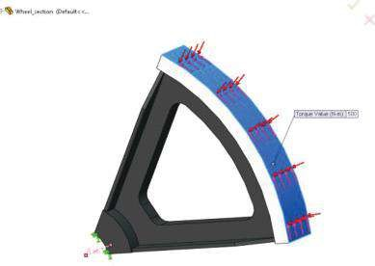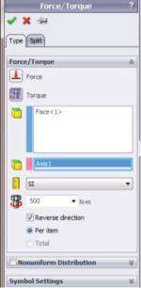

###### Figure 6.38

*Input of the torque. (a) Torque property manager. (b) Graphical view when Torque property manager is active.*

***Table 6.3***

#### Numerical Results for Segmented Models, Restrained by Different Fixtures (Scenario 2)

**Bearing Fixture Studies with Axial**

**Study with Study with**

**Bearing Resistance Equal to Fixed Cylindrical**

|  |  |  |  |  |  |
| --- | --- | --- | --- | --- | --- |
|  | **Geometry Fixture** | **Faces Fixture Study 1** | **10 N/m Study 2** | **5 N/m** | **0 N/m Study 3** |
| **von Mises Stress (MPa)** Element Mode – max | 140.5 | 216.8 | 140.5 | 140.5 | 140.5 |
| Node Mode – max | 160.6 | 236.9 | 160.6 | 160.6 | 160.6 |
| **Principal Stress P1 (MPa)** Element Mode – max | 76.5 | 144.1 | 76.5 | 76.5 | 76.5 |
| Node Mode – max | 89.4 | 159.8 | 89.4 | 89.4 | 89.4 |
| **Principal Stress P3 (MPa)** Element Mode – min | −149.0 | −156.4 | −148.9 | −148.9 | −149.0 |
| Node Mode – min | −167.8 | −177.8 | −167.8 | −167.8 | −167.8 |
| Maximum D isplacement (mm) | 0.452 | 2.353 | 0.609 | 0.599 | 0.452 |
| Corresponding Axial D isplacement (mm) | 4.971e−03 | 1.248 | 0.4053 | 0.3902 | 4.971e−03 |
| Min Factor of Safety | 1.70 | 0.81 | 1.70 | 1.70 | 1.70 |

As far as the stress distribution is concerned, the use of the bearing fixture is equal to the **Fixed Geometry** fixture. Generally, the bearing fixture provides different nodes’ displacements, and consequently different deformations of the body. The displacement values depend on the flexibility of the fixture. Therefore, **the** **rigid bearing** can successfully substitute the **Fixed Geometry**, as far as the object deformations are concerned.

(a)

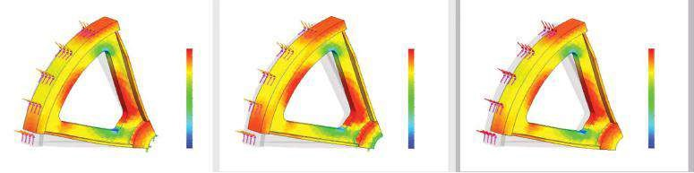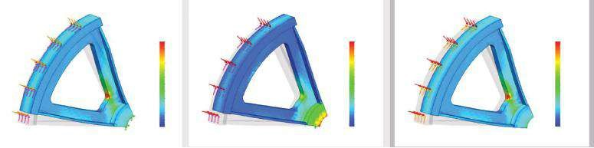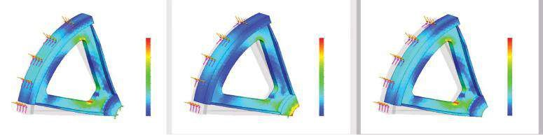

)

b

(

)

(

c

Model name: Wheel_section

Study name: Asymmetric Study_Fixed_Geometry

Plot type: Static element stress Stress1

Deformation scale: 40

Model name: Wheel_section

Study name: Asymmetric Study_Fixed_Geometry

Plot type: Static element stress Stress2

Deformation scale: 40

Model name: Wheel_section

Study name: Asymmetric Study_Fixed_Geometry

Plot type: Static element stress Stress3

Deformation scale: 40

Model name: Wheel_section

Study name: Asymmetric Study_Advanced_Fixture

Plot type: Static element stress Stress1

Deformation scale: 10

Model name: Wheel_section

Study name: Asymmetric Study_Advanced_Fixture

Plot type: Static element stress Stress2

Deformation scale: 10

Model name: Wheel_section

Study name: Asymmetric Study_Advanced_Fixture

Plot type: Static element stress Stress3

Deformation scale: 10

Model name: Wheel_section

Study name: Asymmetric Study_Bearing_Fixture

Plot type: Static element stress Stress1

Deformation scale: 40

Model name: Wheel_section

Study name: Asymmetric Study_Bearing_Fixture

Plot type: Static element stress Stress2

Deformation scale: 40

Model name: Wheel_section

Study name: Asymmetric Study_Bearing_Fixture

Plot type: Static element stress Stress3

Deformation scale: 40

von Mises (N/mm

2

(MPa))

P1 (N/mm

2

(MPa))

P3 (N/mm

2

(MPa))

P3 (N/mm

2

(MPa))

P3 (N/mm

2

(MPa))

4.8

-8.0

-20.8

-33.7

-46.5

-59.3

-72.1

-84.9

-97.7

-110.5

-123.3

-136.1

-148.9

5.6

-7.8

-21.4

-34.9

-48.4

-61.9

-75.4

-88.9

-102.4

-115.9

-129.4

-142.9

-156.4

4.8

-8.0

-20.8

-33.7

-46.5

-59.3

-72.1

-84.9

-97.7

-110.5

-123.3

-136.1

-149.0

P1 (N/mm

2

(MPa))

144.1

131.0

117.8

104.7

91.6

78.4

66.3

52.2

39.0

26.9

12.8

-0.4

-13.5

78.5

69.1

61.7

54.4

47.0

39.6

32.2

24.8

17.4

10.1

2.7

-4.7

-12.1

78.5

69.1

61.7

54.3

47.0

39.6

32.2

24.8

17.4

10.1

2.7

-4.7

-12.1

von Mises (N/mm

2

(MPa))

von Mises (N/mm

2

(MPa))

140.5

128.9

117.2

105.5

90.8

82.1

70.4

58.7

47.0

35.4

23.7

12.0

0.3

198.7

180.7

162.7

144.7

126.6

108.6

90.6

72.6

54.6

38.5

18.5

0.5

216.8

140.5

128.9

117.2

105.5

93.8

82.1

70.4

58.7

47.0

35.4

23.7

12.0

0.3

(d)

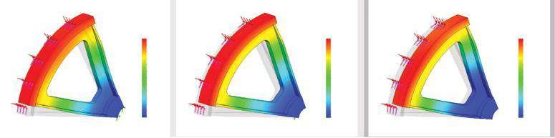

Mo

del name: Wheel_section

Study name:

Asymmetric Study_Fixed_Geometry

Plot ty

pe: Static displacement Displacement1

De

formation scale: 40

Model name: Wheel_section

Study name: Asymmetric Study_Bearing_Fixture

Plot type: Static displacement Displacement1

Deformation scale: 40

Model name: Wheel_section

Study name: Asymmetric Study_Advanced_Fixture

Plot type: Static displacement Displacement1

Deformation scale: 10

URES (mm)

URES (mm)

URES (mm)

6.094e-001

5.916e-001

5.742e-001

5.567e-001

5.391e-001

5.215e-001

5.040e-001

4.864e-001

4.588e-001

4.513e-001

4.337e-001

4.162e-001

3.956e-001

4.521e-001

2.353e+000

2.261e+000

2.168e+000

2.078e+000

1.986e+000

1.896e+000

1.803e+000

1.711e+000

1.620e+000

1.526e+000

1.436e+000

1.345e+000

1.253e+000

4.144e-001

3.767e-001

3.391e-001

3.014e-001

2.637e-001

2.260e-001

1.884e-001

1.507e-001

1.130e-001

7.536e-002

3.767e-002

1.000e-030

(e)

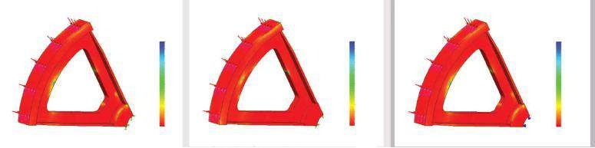

Model name: Wheel_section

Study name: Asymmetric Study_Fixed_Geometry

Plot type: Factor of Safety Factor of Safety1

Criterion: Automatic

Factor of safety distribution: Min FOS = 1.7

Model name: Wheel_section

Study name: Asymmetric Study_Advanced_Fixture

Plot type: Factor of Safety Factor of Safety1

Criterion: Automatic

Factor of safety distribution: Min FOS = 0.81

Model name: Wheel_section

Study name: Asymmetric Study_Bearing_Fixture

Plot type: Factor of Safety Factor of Safety1

Criterion: Automatic

Factor of safety distribution: Min FOS = 1.7

FOS

FOS

FOS

878.79

808.47

858.01

785.65

715.29

643.83

572.57

501.21

429.85

358.49

287.13

215.77

144.42

73.06

1.70

741.16

673.86

606.55

539.25

471.94

404.84

337.33

270.03

202.72

135.42

68.11

0.81

805.70

732.61

659.52

586.43

513.33

440.24

367.15

294.06

220.97

147.88

74.79

1.70

##### Fig u r e 6.39

*Plots of the bearing studies. (a) von Mises Stresses plot. (b) First Principal Stress P1 plot. (c) Third Principal Stress P3 plot. (d) Resultant displacem ent plot. (e) Factor of safety plot.*

In this section, we studied a machine unit with axi-symmetrical geometry, loaded with symmetrical or anti-symmetrical loads, and compared different results. Some test studies were provided.

|  |
| --- |
| We learned how to perform a finite element analysis of a segment of a unit with circular symmetry using the symmetry to simplify the model, without any reduction of the results’ accuracy. We applied  • Symmetric boundary conditions using Symmetric and Circular Symmetry fixtures • Bearing fixtures |

### 6.3 STATIC ANALYSIS OF THE DESIGNED SYMMETRICAL MACHINE UNITS WITH A PLANAR SYMMETRY

#### 6.3.1 Defining the Analysed Segment

We start our case study with cutting the half of the body. The new part is titled **Machine_element_section**.

To cut the half of the unit, the next stages are performed:

1. Sketching the intersection of the body with the **Right Plane** of symmetry (Figure 6.40a)

Sketch → Convert Entities tool () → Intersection Curve () →OK

Pick all intersecting **Right Plane** faces (Figure 6.40b). As a result, their signatures will be displayed at the blue window on the **Intersection Curves** property manager (Figure 6.40c). The software draws the intersecting contour and titles it **Sketch10** (Figure 6.40d).

1. Cutting the unnecessary part. The generated **Sketch10** will be used for extrusion.

Feature → Extruded Cut () → OK

The extrusion will pass through all bodies (Figure 6.41a and b), and only the uncut part of the object (blue body in the figure, Figure 6.41c and d) will be kept for future analysis (Figure 6.41e).

#### 6.3.2 Static Study of a Body with Planar Symmetry and Symmetrical Loads

Let us suppose that there are two small shafts (the orange components) pressed in the horizontal side cylinder components of the units. They are exposed to torsion in two opposite directions. The unit is fixed to the ground by two pins (the blue components in Figure 6.42). Further **Grounded Bolt** fixtures will substitute these pins.

The new static study is titled the **Symmetrical Study**.

(a) (b)

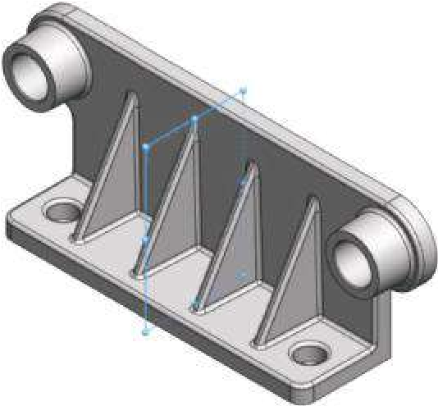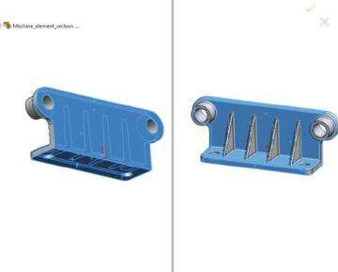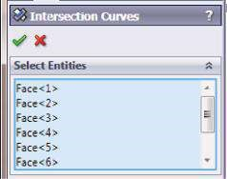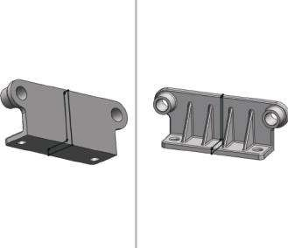

(

c

)

(

d

)

Righ

t Plane

##### Figure 6.40

*Development of intersection of the object and the symmetrical plane. (a) Plane of symmetry. (b) Intersected faces. (c) Intersection Curves property m anager. (d) Intersected sketch – Sketch10.*

The selected material is the **Gray Cast Iron**. As it possesses very good damping properties, the unit will successfully damp the vibrations of the shafts and will limit the vibrations’ impact on the external environment. The material is picked from

SW Simulation Materials → Iron → Gray Cast Iron

Its **Tensile Strength** is 151.66 MPa, the **Compressive Strength** is 572.15 MPa and the **Default failure criterion** is the **Mohr–Coulomb Stress**. The first fixture to be defined is the **Grounded Bolt** ():

Fixtures → Grounded Bolt…

It sets a bolt connector between the selected component and the ground.

In advance, the **Rigid Virtual Wall** contact must be defined. It is situated in a plane at the bottom of the horizontal component of the unit (Figure 6.43b). Its signature will be **Plane2** (Figure 6.43a and b) and it is created through the path

Feature → Reference Geometry → Plane () → OK

**Virtual Wall** is created by the following path:

(a) (b) (c)

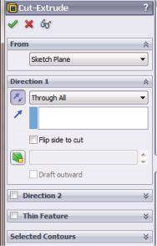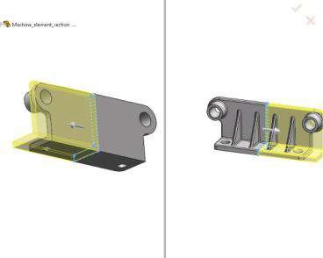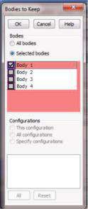

(d) (e)

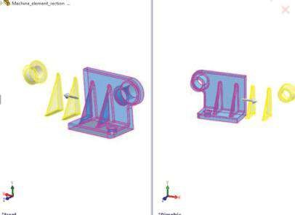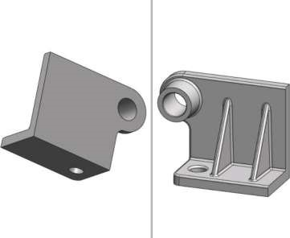

##### Fig u r e 6.41

*Cut half of the object. (a) Cut-Extrude property manager. (b) Graphic area view when CutExtrude comm and is active. (c) Bodies to Keep window. (d) Selected body to be kept. (e) Cut object.*

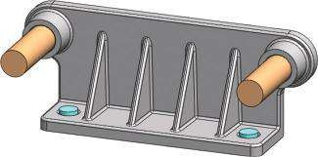

##### Figure 6.42

*CAD model of the studied machine unit.*

Connections ()→ Contact Sets () → OK

When the **Contact Sets** property manager opens (Figure 6.43c), the way of introducing the contact entities and the type of the contact (**Virtual Wall** in the **Type** sub-window) must be selected (**Manually select contact sets** in our case). **Virtual Wall** is used to define the contact between the **Set 1** entities (in the blue window of the **Contact Sets** property manager) and the **target plane** (in the violet window). The

(a) (b)

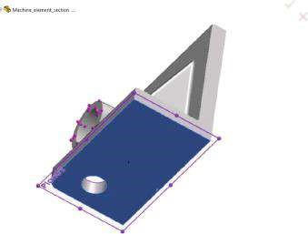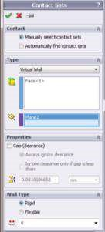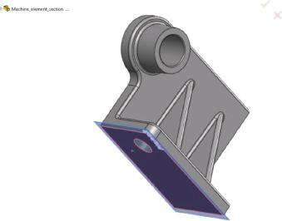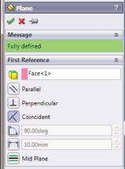

(

c

)

(

d

)

##### Figure 6.43

*Defining the Rigid Virtual wall. (a) Plane property manager. (b) Selected face, which coincides with the plane. (c) Contact Sets property manager. (d) Graphic area view while Virtual Wall is being defined.*

target plane may be rigid or flexible. Additionally, a friction between both sets can be defined by entering a non-zero value of the friction coefficient (, Figure 6.43c and d). The **Ground Bolt** definition may be done according to the following instructions:

1. Setting **the type of the connector** (Figure 6.44a and b). Pick the type of the bolt – Foundation Bolt (); select an edge to define the bolt head and the bolt nut location () – Edge<1>; select a plane to model the virtual wall () – Plane2. The rigid virtual wall prevents the bolt’s penetration into the foundation. After that, the values of the **Nut Diameter** () and the **Bolt Shank Diameter** () must be entered. The value for the **Bolt Shank Diameter** () should be equal to or less than the diameters of the **Thread face** – 12 mm. By default, the program multiplies the shank diameter by a factor of 1.5 to obtain the nut diameter – 18 mm.
2. Definition of **Tight Face** (Figure 6.44c) – It is selected if the radius of the shank is equal to the radius of the cylindrical face associated with at least one of the connected components (). The software assumes that the preselected cylindrical face is rigid and that it deforms with the shank as a rigid body. More than one cylindrical face can be selected, but they must have the same axis and radius. This option is not active in our study.

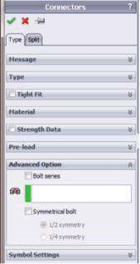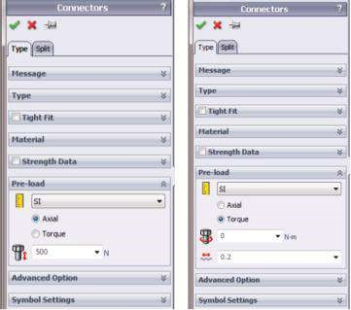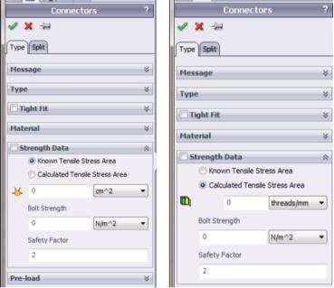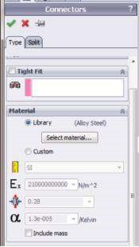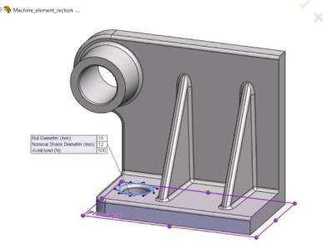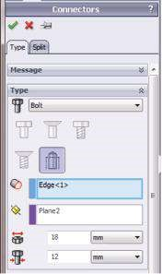

(

)

a

(

d

)(

e)

(

f

)

(

b

)

(

)

c

***Figure 6.44***

*Defining the Ground Bolt fixture. (a) Connectors property manager – Type sub-window. (b) Selected the rigid virtual wall, which coincides with Plane2.*

*(*

*c) Connectors property manager – Material sub-window. (d) Connectors property manager – Strength Data sub-window. (e) Connectors property*

*manager – Pre-load sub-window. (f) Connectors property manager – Advanced Option sub-window.*

1. Definition of the **Material** (Figure 6.44c) – By default, the material of the bolt is set to be **Alloy steel** from the **SW Simulation Material** library. It can easily be changed by pressing the **Select Material…** () button and selecting another material from the library (the **Library** button is checked) or by checking the **Custom** button and defining the properties of a new material. The material properties expected by the program are **Units** (), **Young’s Modulus** (), **Poisson’s Ratio** () and **Thermal expansion coefficient** (α). Optionally the mass of the bolt can be included in the analysis ().
2. The next sub-window is the **Strength Data** (Figure 6.44d) sub-window, which has two versions:
   * **Known tensile stress area** – this option must be selected if **the tensile stress area** is known. The user inputs the area (), which equals the minimum area of the threaded section of the bolt (in mm2), **Bolt Strength**

(in MPa) and **Safety Factor** for pass/no pass design check of the bolt.

* + **Calculated tensile stress area** – if this option is selected, the program calculates the tensile stress area of the bolt according to the formula

*AT* = 0.7854*(*Dn* −0.9382/*n* )2

where *AT* equals the tensile stress area, *Dn* is the nominal shank diameter, *p* is the thread pitch and *n* =1/*p* is the **Thread Count** () or threads per millimetre (thread/mm) measured along the length of the fastener. **Bolt Strength** sets the strength of the bolt’s material and its unit. There are three commonly used strength parameters for bolts to estimate bolt failure: Yield strength, Ultimate Strength and Proof Strength (90% of Yield strength). The most commonly used parameter of all is the Yield strength of the bolt’s material or grade, but the user can choose the most appropriate for the application value. Finally, the **Safety Factor** is input. The bolt fails when its combined load exceeds the ratio of **1/Safety Factor**. The **design check** of the bolt checks whether a bolt can safely carry the applied loads, or it will fail. The software calculates the combined load ratio a connector withstands and compares it with the user-defined factor of safety. All used equations are given in Table 6.4.

1. After that is the **Pre-load** sub-window (Figure 6.44d), which also has two options:
   * **Axial** ( ) – recommended if the axial load on the bolt is known.
   * **Torque** ( ) – used if the torque used to tighten the bolt is known. If the **Torque** option is checked, the program uses the **Friction Factor** (**K**,) to calculate the axial force from the given torque. The following formulas are used:



*F* = *T*  for a bolt with a nut and a torque applied on the nut

##### K D*

*F* = *T* for a bolt without a nut and a torque applied on the head 1.2\**K D*\* where *F* is the axial force in the bolt, *T* is the applied torque, *K* is the friction factor and *D* is the major diameter of the shank.

In our case, the axial load in the bolt is introduced (500 N).

***Table 6.4***

#### Formulas for Bolt Safety Checks

**Loading**

**Formula**

**Notation**

Axial load ratio *R* = *F*

*A*

*AT*\**S*

Bending load ratio *R* = *D n*\**M B*

##### 2* *S I

Shear load ratio *V*

*RS* =

*AT*\**S*

Combined load ratio (*RA* +*RB*)2 +*RS*3

**Pass/No Pass Safety Check**

Connector pass 1

criterion 2 3 >*SF F* – axial load calculated by the software

*AT* – tensile area

*S* – strength value of connector’s material *M* – bending moment calculated by the software

*D n* – nominal shank diameter

*I* – area moment of inertia; it is calculated as *I* =π\**r*4 /4

*V* – shear load calculated by the software

*SF* – user-defined factor of safety

(*RA* + +*RB*) *RS*

Connector no pass 1 <*SF*

criterion

2

3

(

)

*R*

*R*

*R*

*A*

*B*

*S*

++

6. The last is the **Advanced Option** sub-window (Figure 6.44e).

* **Bolt series** are used when more than two components are bolted together. The cylindrical faces of solid bodies that are connected together () must be picked to mark the series.
* **Symmetrical bolt** is used if one or two planes of symmetry cut through the bolt. For one-half symmetry bolts, the plane or planar face of symmetry is selected in the **Reference Geometry** to be ( pink window). If symmetrical bolts are used, one-half or one-fourth of the total pre-load value and one-half or one-fourth of the total mass of the bolt according to the selected symmetry type are entered. Keep in mind that when listing the bolt forces after running the study, the results are equal to one-half or one-fourth of the total force.

The second fixture to be introduced to the model is the **Symmetry Fixture**

(Figure 6.45):

Fixtures()→ Advanced Fixtures → Symmetry

It defines the boundary conditions at the symmetrical plane and sets the translation normal to the selected face restrained.

Thus, all fixtures applied to the half of the unit are introduced.

The next stage is the introduction of the external loads. Three different types of loads will be input.

(a) (b)

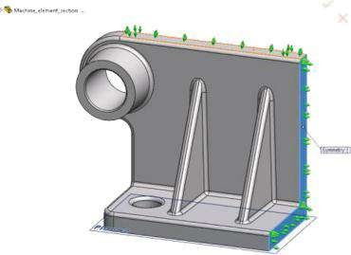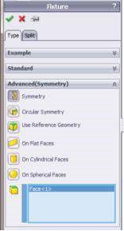

###### Fig u r e 6.45

*Defining the Symmetry Fixture. (a) Symmetry Fixture property manager. (b) Graphic area view when Symmetry Fixture property manager is active.*

1. **Gravity** (, marked with a big red arrow) is perpendicular to the **Top Plane**, and its value is equal to the earth’s acceleration – 9.81 m/s2 (Figure 6.46):

External Loads → Gravity () → OK

1. **Pressure** (, marked by small red arrows) models the joint between the studied machine unit and the shaft, which is pressed in the hole (Figures 6.42 and 6.47):

External Loads → Pressure () → OK

1. **Torque** (, marked by small magenta arrows) models the torsion of the shaft. It is important to keep in mind that the torsion of both shafts is counter-wise, anti-clockwise for the studied segment (Figures 6.42 and 6.48):

External Loads → Torque () → OK

(a) (b)

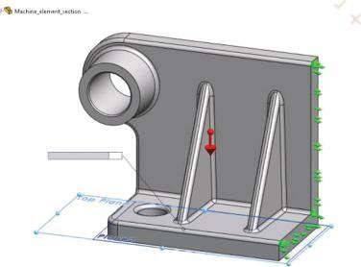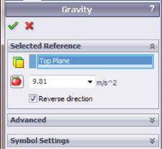

Normal To Plane (m/s

2

):

9.61

###### Figure 6.46

*Defining the Gravity load. (a) Gravity property manager. (b) Graphic area view when Gravity property manager is active.*

(a) (b)

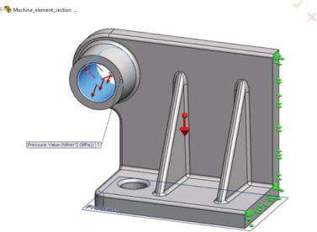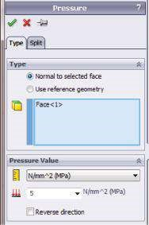

###### Fig u r e 6.47

*Defining the Pressure load. (a) Pressure property manager. (b) Graphic area view when Pressure property manager is active.*

(a) (b)

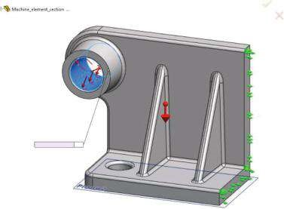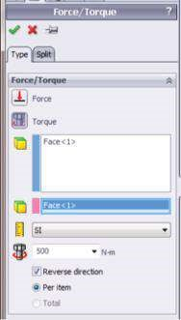

Torque Value (N-m):500

###### Figure 6.48

*Defining the Torque load. (a) Torque property m anager. (b) Graphic area view when Torque property manager is active.*

The last stage in the development of the FE model is the creation of the mesh. A **Curvature-based mesh** with a maximal size of FEs of 5 mm and a minimal size of FEs of 1 mm is selected (Figure 6.49a and b). Each FE has 29 Jacobian points. The total number of the FEs is 73,617, whereas the total number of the nodes is 113,797. There are a few badly configured FEs, with an Aspect ratio of > 10 (Figure 6.49c). Therefore, mesh control () at the hole faces is applied (Figure 6.49d and e). The new mesh consists of 109,384 FEs and 166,229 nodes. There are no FEs with Aspect ratio > 10 (Figure 6.49f and g).

The next stage is to run the model. The solver solves the system of about 355,350 equations, which equals the number of DOFs.

Some results of this study are given in Figure 6.50. In the context of the studied symmetrical boundary conditions, it is reasonable to pay special attention to the **UX** plot,

(a) (b)

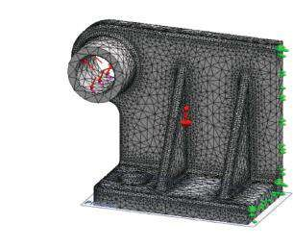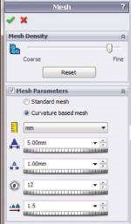

Model name: Machine_element_section

Study name: Symmetrical Study

Mesh type: Solid mesh

Educational Version. For Instructional Use Only

(c)

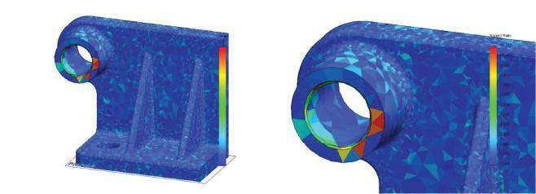

Mo

del name: Machine_element_section

Study name: Sy

mmetrical Study

Plot ty

pe: Aspect ratio Mesh Quality1

Model name: Machine_element_section

Study name: Symmetrical Study

Plot type: Aspect ratio Mesh Quality1

Aspect Ratio

10.867

10.049

9.230

8.411

7.593

6.774

5.956

5.137

4.318

3.500

2.681

1.862

1.044

(d) (e)

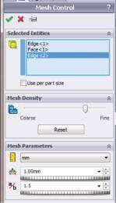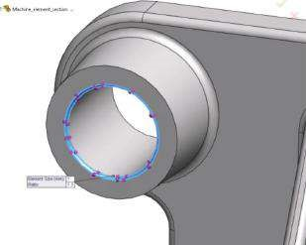

(f) (g)

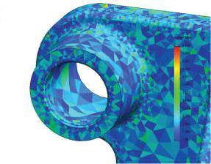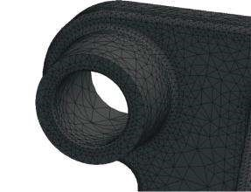

Model name: Machine_element_section

Study name: Symmetrical Study

Mesh type: Solid mesh

Model name: Machine_element_section

Study name: Symmetrical Study

Plot type: Aspect ratio Mesh Quality1

###### Fig u r e 6.49

*Meshing the m odel. (a) Mesh property m anager. (b) Plot of the created m esh. (c) Aspect Ratio plot of the designed m esh. (d) Mesh Control property m anager. (e) Faces to which m esh control is applied. (f) Mesh after Mesh Control is activated. (g) Aspect Ratio plot after Mesh Control is activated.*

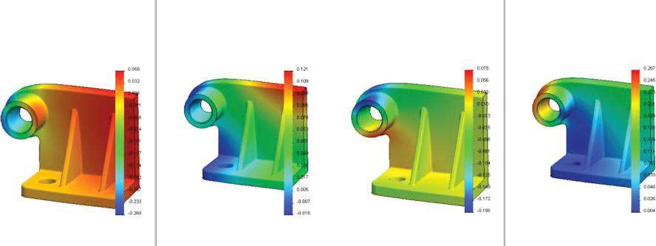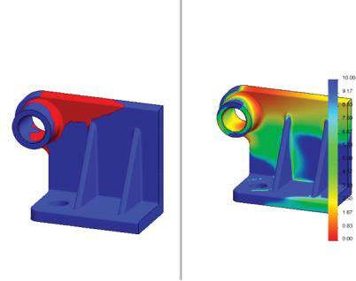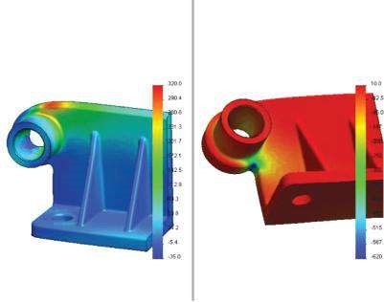

a

)

(

c

)

(

(

b

)

Mo

del name: Machine_element_se

ction_4

Study name: Sy

mmetrical Stud

y

Plot ty

pe

:

Static element stress Stress

1

De

fo

rm

ation

scale: 37.7203

Mo

del name: Machine_element_se

ction_4

Study name: Sy

mmetrical Stud

y

Plot ty

pe

Static displacement Displacement

:

1

De

fo

rm

ation

scale: 37.7203

Mo

del name: Machine_element_se

ction_4

Study name: Sy

mmetrical Stud

y

Plot ty

pe

Static displacement Displacement

:

1

De

fo

rm

ation

scale: 37.7203

Mo

del name: Machine_element_se

ction_4

Study name: Sy

mmetrical Stud

y

Plot ty

pe

:

Static displacement Displacement

1

De

fo

rm

ation

scale: 37.7203

Mo

del name: Machine_element_se

ction_4

Study name: Sy

mmetrical Stud

y

Plot ty

pe

:

Static displacement Displacement

1

De

fo

rm

ation

scale: 37.7203

UY

(mm)

UZ (mm)

UX

(mm)

URES (mm)

Mo

del name: Machine_element_se

ction_4

Study name: Sy

mmetrical Stud

y

Plot ty

pe

2

Static element stress Stress

:

De

fo

rm

ation

scale: 37.7203

Mo

del name: Machine_element_se

ction_4

Study name: Sy

mmetrical Stud

y

Plot ty

pe

Static element stress Stress

2

:

Criterion:

Au

tomati

c

Re

d < FOS = 2 < Blue

Mo

del name: Machine_element_se

ction_4

Study name: Sy

mmetrical Stud

y

Plot ty

pe

:

Fa

ct

or of Sfaety

FA

ct

or of Safety1

Criterion:

Au

tomati

c

Fa

ct

or of safety distribution: Min FOS = 0.45

FO

S

P1 (N/m

m

2

(MPa))

P3 (N/m

m

2

(MPa))

***Figure 6.50***

*Results for symmetrical model with four ribs. (a) von Mises stresses plot. (b) Factor of safety plots. (c) Displacement plots.*

admitting that UX = 0 for all nodes in the symmetrical face (Figure 6.50c). The most important conclusions about the obtained results are as follows:

* The extreme values of the tensile and the compressive stresses (Figure 6.50a) are far beyond the material strengths, and this is dangerous (maxP1 = 307 MPa compared to the tensile strength of the material of 151.7 MPa and minP3 = 628 MPa compared to 572 MPa compressive strength of the material).
* The minimal Factor of Safety is 0.45, and a large area of the material could not reach the indicative value of 2 FoS (Figure 6.50b).

As usual, the loads are pre-defined and could not be modified; a new design of this machine unit should be investigated.

The first idea that comes into a user’s mind is to increase the number of the ribs and thus to make the construction less flexible. In fact, while studying this element, we see that the FoS problem is disposed at the area of the element, where the side cylinder component, which supports the shaft, joins the vertical plate. Thus, it is questionable whether the variation of the ribs will solve the problem. The CAD model was developed using the **LPattern** command; hence, it is easy to modify the machine unit by changing the number of ribs to six or two. As it is seen in Figure 6.51, the modifications of the ribs do not help to reduce the stress. Even more, the minimal FoS is reduced to 0.38. Thus, another solution must be searched.

Three different modifications of the unit’s construction are discussed here:

* Increase in the outer diameter of the component that supports the shaft from ϕ28 mm to ϕ32 mm. The results are given in Figure 6.52a. The maximal displacement is decreased to 0.257 mm. The maximal tensile stress (maxP1) is decreased to 297 MPa, and the maximal compressive stress (minP3) is 577 MPa. These values are still larger than the tensile strength and the compressive strength of the material. Hence, a design modification of entirely different type must be discussed.
* To increase the thickness of the vertical plate from 8 to 16 mm. The results are given in Figure 6.52b. The maximal tensile stress (maxP1) is decreased to 190 MPa, and the maximal compressive stress (minP3) to 322 MPa. While the maximal tensile stress is still larger than the tensile strength of the material, the compressive strength is far below the limit. Thus, the area with the maximal tensile stress remains vulnerable. The maximal displacement is decreased to 0.14 mm, minimal FoS is 0.63 and the areas where the FoS coefficient is smaller than 2 are limited compared to all previous modifications.
* The last design modification presented here involves an increase in the outer diameter of the shaft support to 32 mm and a new design of the vertical plate, which thickness is set to 10 mm (Figure 6.52d). The extreme stresses are far below the strengths of the material, yet there are areas where the FoS is smaller than 2. This can easily be overcome by changing the radius of the fillet.

The conclusion is that the last design satisfies the initial safety requirements for the unit, made of Gray Cast Iron.

If the material of the machine unit is changed to **Alloy Steel**, the factor of safety significantly increases and its minimal value is 0.96. The areas, where FoS is below 2, are also limited (Figure 6.53).

Therefore, regarding the failure criterion, Alloy Steel for that machine unit can be a significantly better solution than Gray Cast Iron.

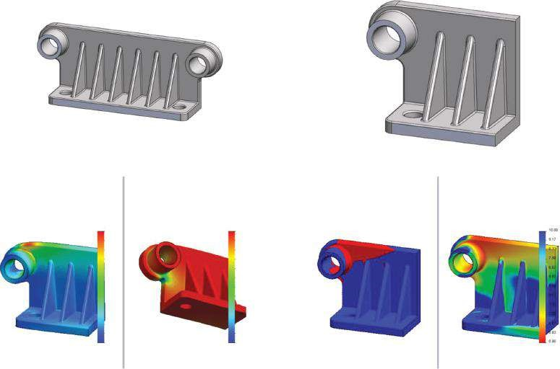

(

a

)

Model name: Machine_element_section_2

Study name: Symmetrical Study

Plot type: Static element stress Stress2

Deformation scale: 37.9192

Model name: Machine_element_section_2

Study name: Symmetrical Study

Plot type: Static element stress Stress3

Deformation scale: 37.9192

Model name: Machine_element_section_2

Study name: Symmetrical Study

Plot type: Factor of Safety Factor of Safety1

Criterion: Automatic

Red < FOS = 2 < Blue

Model name: Machine_element_section_2

Study name: Symmetrical Study

Plot type: Factor of Safety Factor of Safety2

Criterion: Automatic

Factor of safety distribution: Min FOS = 0.39

FOS

P1 (N/mm

2

(MPa))

320.0

290.4

260.6

231.3

201.7

172.1

142.5

112.9

83.3

53.8

24.2

-5.4

-35.0

-620.

-567.

-515.

-

?

-410.

-357.

-305.

-252.

-200.

-147.

-95.0

-42.5

10.0

P3 (N/mm

2

(MPa))

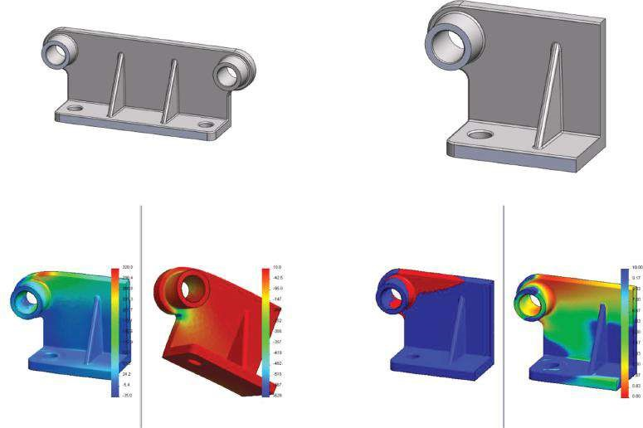

(

b

)

Mo

del name: Machine_element_section_3

Study name: Sy

mmetrical Study

Plot ty

pe: Static element stress Stress2

De

formation scale: 37.898

Model name: Machine_element_section_3

Study name: Symmetrical Study

Plot type: Static element stress Stress3

Deformation scale: 37.898

P1 (N/mm

2

(MPa))

P3 (N/mm

2

(MPa))

Model name: Machine_element_section_2

Study name: Symmetrical Study

Plot type: Factor of Safety Factor of Safety1

Criterion: Automatic

Red < FOS = 2 < Blue

Model name: Machine_element_section_3

Study name: Symmetrical Study

Plot type: Factor of Safety Factor of Safety2

Criterion: Automatic

Factor of safety distribution: Min FOS = 0.38

FOS

###### Fig u r e 6.51

*Results for symmetrical model with six or two ribs. (a) Modification of a machine element with 6 ribs: maxP1 = 313 MPa; minP3 = 600 MPa; max displacement = 0.266 mm; and minFoS = 0.39. (b) Modification of a m achine elem ent with 2 ribs: m axP1 = 318 MPa; minP3 = 615 MPa; m ax displacement = 0.266 mm; and minFoS = 0.38.*

(a)

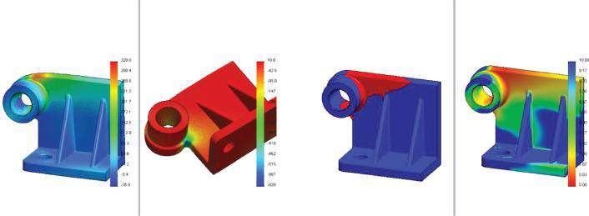

Mo

del name: Machine_element_section_4

Study name: Sy

mmetrical Study

Plot ty

pe: Static element stress Stress1

De

formation scale: 39.3123

Model name: Machine_element_section_4

Study name: Symmetrical Study

Plot type: Static element stress Stress2

Deformation scale: 39.3123

Model name: Machine_element_section_4

Study name: Symmetrical Study

Plot type: Factor of Safety Factor of Safety2

Criterion: Automatic

Red < FOS = 2 < Blue

Model name: Machine_element_section_4

Study name: Symmetrical Study

Plot type: Factor of Safety Factor of Safety1

Criterion: Automatic

Factor of safety distribution: Min FOS = 0.45

P1 (N/mm

2

(MPa))

P3 (N/mm

2

(MPa))

FOS

(b)

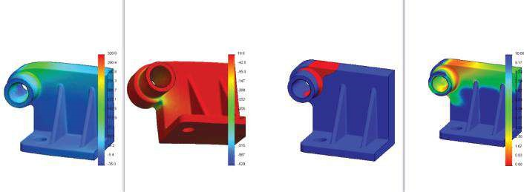

Mo

del name: Machine_element_section_4

Study name: Sy

mmetrical Study

Plot ty

pe: Static element stress Stress1

De

formation scale: 72.0415

Model name: Machine_element_section_4

Study name: Symmetrical Study

Plot type: Static element stress Stress2

Deformation scale: 72.0415

Model name: Machine_element_section_4

Study name: Symmetrical Study

Plot type: Factor of Safety Factor of Safety2

Criterion: Automatic

Red < FOS = 2 < Blue

Model name: Machine_element_section_4

Study name: Symmetrical Study

Plot type: Factor of Safety Factor of Safety1

Criterion: Automatic

Factor of safety distribution: Min FOS = 0.63

FOS

P1 (N/mm

2

(MPa))

P3 (N/mm

2

(MPa))

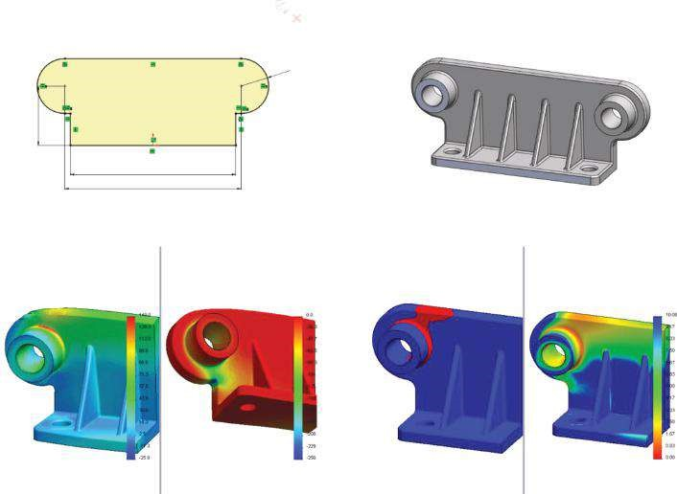

c

)

(

Mo

del name: Machine_element_section_4

Study name: Sy

mmetrical Study

Plot ty

pe: Static element stress Stress1

De

formation scale: 91.7634

Model name: Machine_element_section_4

Study name: Symmetrical Study

Plot type: Static element stress Stress2

Deformation scale: 91.7634

P1 (N/mm

2

(MPa))

P3 (N/mm

2

(MPa))

Model name: Machine_element_section_4

Study name: Symmetrical Study

Plot type: Factor of Safety Factor of Safety2

Criterion: Automatic

Red < FOS = 2 < Blue

Model name: Machine_element_section_4

Study name: Symmetrical Study

Plot type: Factor of Safety Factor of Safety1

Criterion: Automatic

Factor of safety distribution: Min FOS = 0.87

FOS

R25

160

150

54

###### Fig u r e 6.52

*Results for machine elements with different variations, regarding its geometry. (a) Results for a machine element with a larger outer diameter of the shaft support: maxP1 = 295 MPa; minP3 = 577 MPa; max displacement = 0.257 mm; and minFoS = 0.45. (b) Results for a machine element with a thicker vertical plate: maxP1 = 190 MPa; minP3 = 322 MPa; max displacement = 0.144 mm; and minFoS = 0.63. (c) Results for a machine element with a new design of the vertical plate: m axP1 = 140 MPa; minP3 = 243 MPa; m ax displacem ent = 0.121 mm; and minFoS = 0.87.*

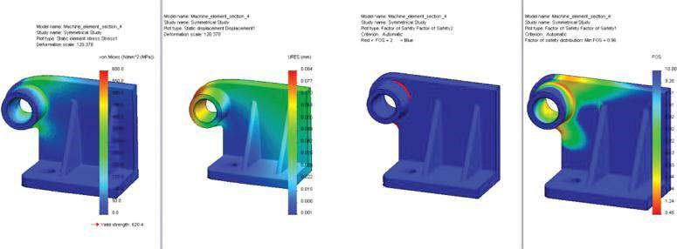

###### Fig u r e 6.53

*Results for a machine element made of Alloy Steel. maxP1 = 582 MPa (Yield Strength = 620 MPa), max displacement = 0.084 mm and minFoS = 0.96.*

In this section, we studied a machine unit with planar symmetrical geometry, exposed to symmetrical boundary conditions.

|  |
| --- |
| We learned how to study a segment of a machine unit with planar symmetrical geometry, exposed to symmetrical loads and under symmetrical restraints, using the symmetry to simplify the model. We learned how to apply   * Gravity load * Symmetric boundary conditions using Symmetric Fixture * Grounded Bolt fixture   We learned how to assess the stress plots when the object is made of brittle material and how to perform factor of safety calculations relying on the Mohr–Coulomb failure criterion.  We discussed a few ways to develop a structural optimisation targeting a reduction of stresses and an increase in the minimal FoS. These are   * Variations in design by adding more supporting elements * Variations in design changing the sketch of some components • Changing the material |

##### . c r c p r e s s . c o m